Academic Taster Workshop
A Level Art & Humanities Subjects

Student Booklet

1. Quiz

Firstly, have a look at these quiz questions and discuss with a partner or think about them on your own. (Answers at the end of the booklet)

- The Prime Minister of the United Kingdom has to be the leader of the political party who win the election– true or false? ​

- The Vedas are the oldest scriptures of which religion?​
- Which country has the largest coastline?
Australia, Canada, Norway or Russia​
- 4. What are the two most aesthetically complementing colours? ​

- Which poet and feminist scholar wrote the often-shared quote: ​
“The master's tools will never dismantle the master's house”?

- As a musician what do you do when you read the word Forte?​​

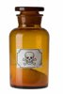
- Nobility in the 16th century would often wear cosmetics containing poison – true or false?

- If a person's actions have bad consequences, it doesn't matter what their intentions were - true or False? ​

Next, think about/discuss: In which subject/s do you think you might get to investigate these sorts of topic?

2. Arts & Humanities Subjects – What is it like to study Arts & Humanities subjects at A Level?

On the next few pages you will find some descriptions of A Level subjects. See if you can identify which subject each description belongs to.
- Write the number of each description in the grid provided below
- You should be able to find 3 descriptions belonging to each activity:
- A description or definition of the subject
- Reasons why you might choose to study the subject at A Level
- A taste of what it’s like to study the subject at A Level

Subject | Description or definition of the subject | Why might you choose to study this subject? | What is it like to study this subject at A Level?
Art & Design

Music
Drama
English Literature
History
Geography
Religious Studies
Politics
Philosophy

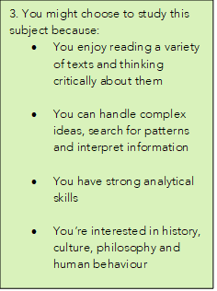
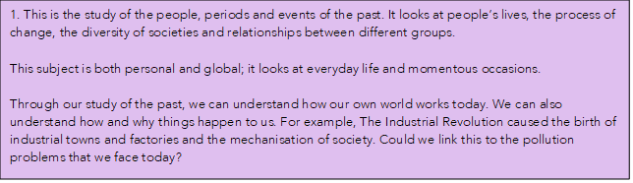
2. If you choose to study this subject, you might cover topics such as religious experience, the nature of God and religious language. You might also look at ethical topics such as euthanasia, abortion or genetic engineering.
It’ll help you to develop skills that are widely transferable to other areas of study and to the professional world.
Studying this subject will:
- help you to develop your ability to reason
- improve your ability to critique the views of others
- teach you to get to the heart of an issue
- clarify and improve your communication skills
- help you to organise your thoughts rationally and present them in a clear way.

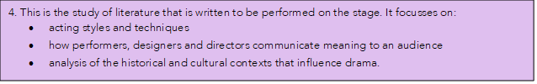

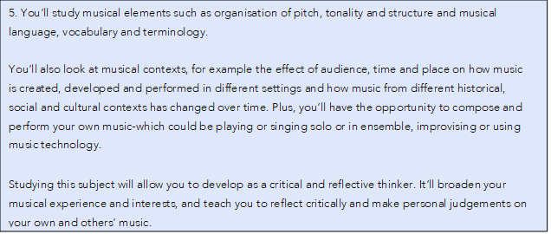

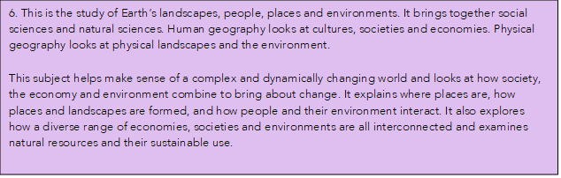
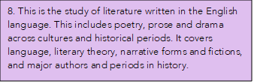
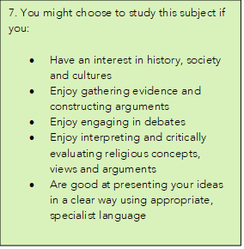

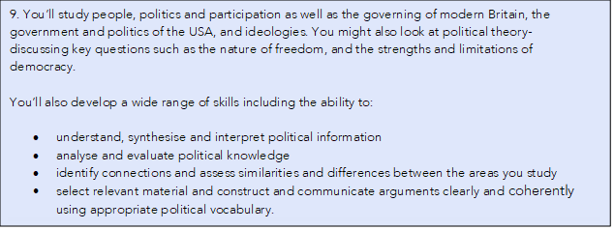

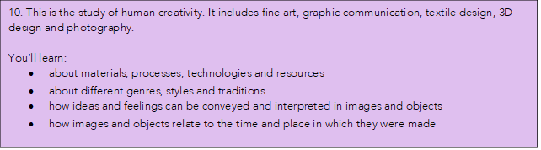

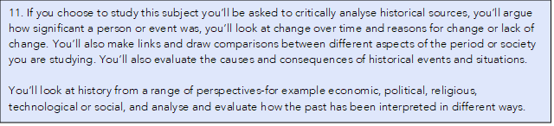
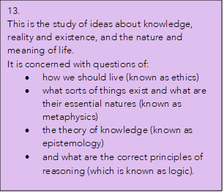
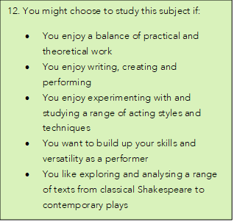

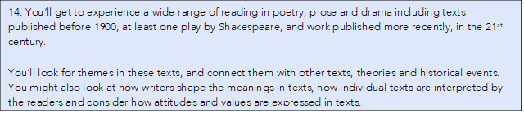

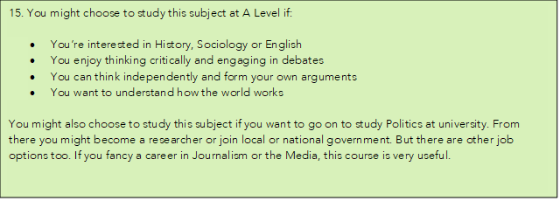

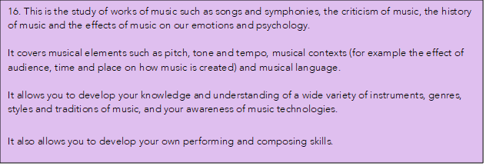

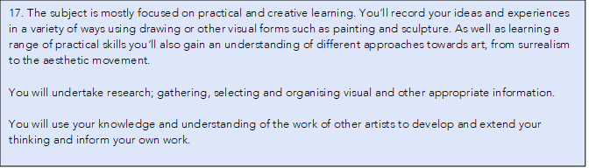
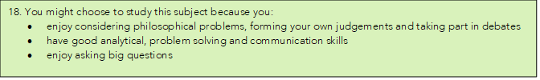

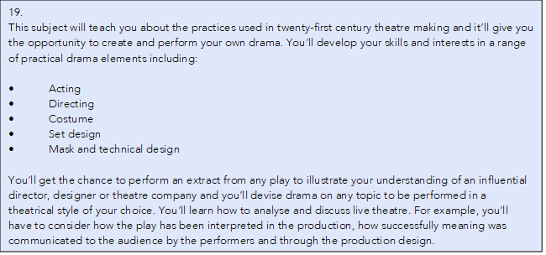
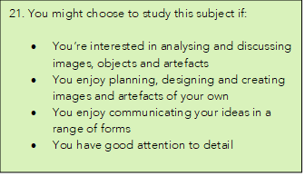
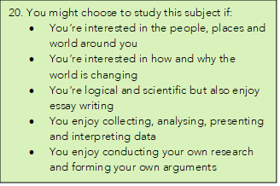
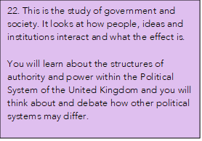

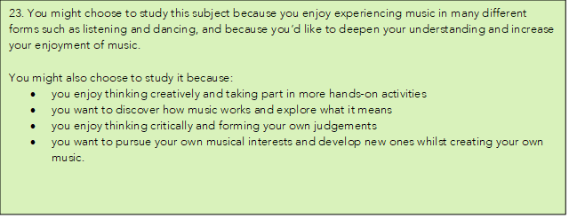

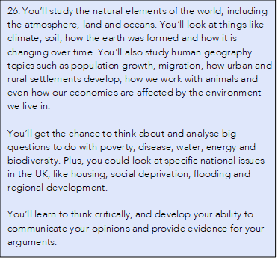
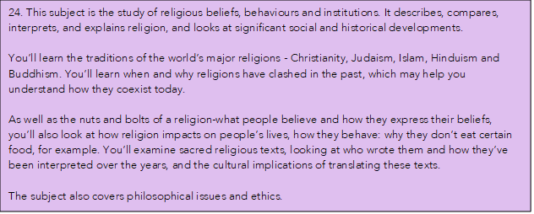
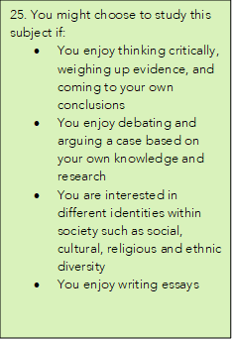

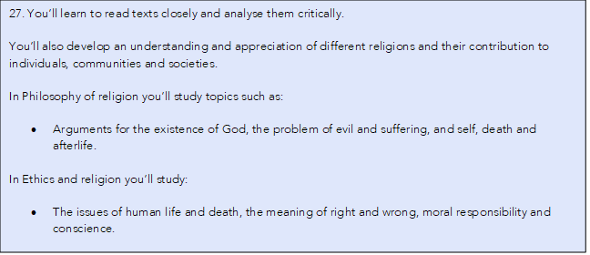
3. Academic Research Activity

Choose a subject you are interested in from the list below.

- Click on the links to download a selection of resources about a specific topic for you to investigate.

- Use the information in the resource pack to find out more about this topic.

- Answer the questions in the pack.

EXTENSION: you can do your own additional wider research if you wish.

Subject | Resource Pack Links
Art & Design | Art & Design Resource Pack.docx
Music | Music Resource Pack.docx
Drama | Drama Resource Pack.docx
English Literature | English Literature Resource Pack.docx
History | History Resource Pack.docx
Geography | Geography Resource Pack.docx
Religious Studies | Religious Studies Resource Pack.docx
Politics | Politics Resource Pack.docx
Philosophy | Philosophy Resource Pack.docx

4. Writing up your research

Academic Word List

- This is a useful resource to help you to learn the words most needed to study at A Level and university.
- The list contains 570 words that are appear most frequently across a range of academic texts.
- The list does not include words that are in the most frequent 2000 words of English.

List 1
access | adequate | annual | apparent
approximated | attitudes | attributed | civil
code | commitment | communication | concentration
conference | contrast | cycle | debate
despite | dimensions | domestic | emerged
error | ethnic | goals | granted
hence | hypothesis | implementation | implications
imposed | integration | internal | investigation
job | label | mechanism | obvious
occupational | option | output | overall
parallel | parameters | phase | predicted
principal | prior | professional | project
promote | regime | resolution | retained
series | statistics | status | stress
subsequent | sum | summary | undertaken

List 2
academic | adjustment | alter | amendment
aware | capacity | challenge | clause
compounds | conflict | consultation | contact
decline | discretion | draft | enable
energy | enforcement | entities | equivalent
evolution | expansion | exposure | external
facilitate | fundamental | generated | generation
image | liberal | licence | logic
marginal | medical | mental | modified
monitoring | network | notion | objective
orientation | perspective | precise | prime
psychology | pursue | ratio | rejected
revenue | stability | styles | substitution
sustainable | symbolic | target | transition
trend | version | welfare | whereas

List 3
abstract | accurate | acknowledged | aggregate
allocation | assigned | attached | author
bond | brief | capable | cited
cooperative | discrimination | display | diversity
domain | edition | enhanced | estate
exceed | expert | explicit | federal
fees | flexibility | furthermore | gender
ignored | incentive | incidence | incorporated
index | inhibition | initiatives | input
instructions | intelligence | interval | lecture
migration | minimum | ministry | motivation
neutral | nevertheless | overseas | preceding
presumption | rational | recovery | revealed
scope | subsidiary | tapes | trace
transformation | transport | underlying | utility

Choose 2-3 words from the list.

How would you use each of these words in a sentence?

1. ……………………………………………………………………………………………………………………………………………………………………………………………………………………………………………………………………………………………………….

2. ……………………………………………………………………………………………………………………………………………………………………………………………………………………………………………………………………………………………………….

3. ……………………………………………………………………………………………………………………………………………………………………………………………………………………………………………………………………………………………………….

Write a short text (around 300 words) about the topic you have been researching.

- Use the answers you found in the research pack you were using during the last activity.
- Select and summarise the most interesting and important points (for example, pick one thing that surprised you or one thing you learnt that you didn’t know before)
- Make sure your text gives the reader/listener a clear and accurate summary of your research topic.

Write your summary here: …………………………………………………………………………………………………………………………………………………………………………………………………………………………………………………………………………………………………………………………………………………………………………………………………………………………………………………………………………………………………………………………………………………………………………………………………………………………………………………………………………………………………………………………………………………………………………………………………………………………………………………………………………………………………………………………………………………………………………………………………………………………………………………………………………………………………………………………………………………………………………………………………………………………………………………………………………………………………………………………………………………………………………………………………………………………………………………………………………………………………………………………………………………………………………………………………………………………………………………………………………………………………………………………………………………………………………………………………………………………………………………………………………………………………………………………………………………………………………………………………………………………………………

Editing your writing

- Read your text aloud
- Does it make sense?
- Does your text give the reader/listener a clear and accurate summary of your research topic?
- Are there any spelling/grammar mistakes that need correcting?
- Have you used between 5 and 10 words from the ‘Academic Word List’
- Is your text no more than 300 words?

You can write your edited version below.

…………………………………………………………………………………………………………………………………………………………………………………………………………………………………………………………………………………………………………………………………………………………………………………………………………………………………………………………………………………………………………………………………………………………………………………………………………………………………………………………………………………………………………………………………………………………………………………………………………………………………………………………………………………………………………………………………………………………………………………………………………………………………………………………………………………………………………………………………………………………………………………………………………………………………………………………………………………………………………………………………………………………………………………………………………………………………………………………………………………………………………………………………………………………………………………………………………………………………………………………………………………………………………………………………………………………………………………………………………………………………………………………………………………………………………………………………………………………………………………………………………………………………………

Quiz answers:

- FALSE – There is no law that says the Prime Minister must be the leader of the party who wins the general election. The position, including this convention, evolved over time, and is maintained through long standing tradition rather than any official legal document.
- The Vedas are a large body of religious writings from Hinduism and are some of the earliest works of Sanskrit literature. There are four Vedas, with each having four sections.
- Canada - Although Canada is only the second largest country by territory, it has the longest coastline in the world. The coastline of Canada measures approximately 202,080 km over double that of Norway in second with a coastline of 83,281 km.

- In colour theory Blue and Orange are often considered to be the most complementing colours. Like all complementing colours they site opposite each other on a colour wheel, but as a pair have the highest level of contrast giving an easily achievable eye-catching effect. Look out for the pairing in artwork, on movie posters, and even in influencer posts on Instagram.

- Audre Lorde – Lorde was an American writer, librarian and activist who dedicated her work and life to exploring and challenging issues of racism, sexism, homophobia, and classism.
- Play loudly- Meaning literally strong in Italian, in music forte instructs a musician to add emphasises to a section by playing strongly and loudly.
- True – cosmetics could often contain mercury, lead and arsenic leading to metal poisoning. The wearers aim was to achieve a silvery gleaming complexion but often instead got paralysis, madness or even sometimes death.
- Just like most discussions from the discipline of philosophy the answer here is up for debate. If you were to study philosophy, utilitarianism would see this as true; value comes from how much actions create happiness or suffering, but Kantian Ethics argues this is false; the lasting impact or repercussions of one action can often be out of our control.

.

Subject grid answers:
Subject | Description or definition of the subject | Why might you choose to study this subject? | What is it like to study this subject at A Level?
Art & Design | 10 | 21 | 17
Music | 16 | 23 | 5
Drama | 4 | 12 | 19
English Literature | 8 | 3 | 14
History | 1 | 25 | 10
Geography | 6 | 20 | 26
Religious Studies | 24 | 7 | 27
Politics | 22 | 15 | 9
Philosophy | 13 | 18 | 2

