Topic: Google Street View

1.Fact Sheet
History and features
- Google Street View is a technology featured in Google Maps and Google Earth that provides panoramic views along many streets in the world.

- The company’s cars first hit the roads in 2006 and it was launched in 2007 in several cities in the United States, and has since expanded to include cities and rural areas worldwide.

- 2008-Google announced that it was testing face-blurring technology on its photos of the busy streets off Manhattan. The technology uses a computer algorithm to search Google’s image database for faces and blurs them.

- 2008-the drag and drop Pegman icon was introduced as the primary user interface element for connecting from Map’s 2D view into Street View’s 3D view. When Pegman is dropped onto a particular set of coordinates in Google Maps for which Street View data is available, Street View opens and over the whole view of the map window.

- 2013: Business interior views are shown as small orange circles. Businesses such as shops, cafés and other premises can pay a photographer to take panoramic images of the interior of their premises which are then included in Street View. Google sets up program to let third parties borrow the Street View Trekker (a backpack mounted camera) and contribute imagery to Google Maps.

- 2015: A partnership was announced between Street View and the environmental monitoring company Aclima. Cars began carrying sensors to detect pollutants such as nitrogen dioxide, ozone, and particulate matter. In October, support for Google Cardboard was announced allowing users to explore street view in 360 degree virtual reality.

- 2017: Imagery inside the International Space Station is added to Street View.
- 2017: Starting in August, Google allows users to create their own street view-like blue paths, for the connected photospheres that are sufficiently close to one another.

- 2017: On September 5, Google announced that they are improving the quality of the street view panoramic photo revamping its mapping vehicles with all-new high resolution camera systems and AI to capture even better imagery. The new Google cars have been seen in various American cities since March 2017 as well as in Japan since August.

- 2017: Since October, Google allows users to capture Street View imagery using Insta360 Pro, this because several years from now, Google Street View could be available in all countries of the world.

- Street View cars have now snapped more than 80 billion photos in thousands of cities and 85 countries.

- 2018: Google Japan now offers the street view from a dog's perspective.

- August 2018: Street View covers two offshore gas-extraction platforms in the North Sea.

Implementation
- Street View is available as a component of Google Maps, as a web application, and as a mobile application for Android and iOS.

- Streets with Street View images available are shown as blue lines on Google Maps.

Vehicles

- Most photography is done by car. Data recording equipment is usually mounted on the roof of a car.

- A trike (tricycle) was developed to record pedestrian routes including Stonehenge, and other UNESCO World Heritage sites.

- In 2010 a snowmobile-based system captured the 2010 Winter Olympics sites.

- Trolleys have been used to shoot the insides of museums, and in Venice the narrow roads were photographed with back-pack mounted cameras, and canals were photographed from boats.

- A portable back-pack Google Trekker is used in outdoor terrain. For instance, the six main paths up Snowdon were mapped by the Google Trekker in 2015.

Projects
Google Street View uses in-house data-capturing technology that lets you see the world from the comfort of your own device. Here are some of the most interesting projects Google has brought to Street View:
- Petra, Jordan-Google have launched images of the ancient rock-cut city of Petra In Jordan (one of the seven wonders of the world).
- Mont Blanc-Google partnered with photographers, skiers, mountaineers, climbers and runners to build up a library of 360-degree imagery of Mont Blanc, the highest mountain in the Alps.
- The Galapagos-you can even walk in the footsteps of giant Galapagos tortoises now that Street View cameras have made it to the Galapagos Islands. The main idea here was to support the ongoing conservation efforts and scientific studies.
- The Ocean-Google has also launched a batch of underwater Street View imagery that lets you swim with humpback whales off the Cook Islands, dive with Parrot Fish off the coast of Bali or walk on a beach in American Samoa.
- National Parks-Google partnered with the National Park Service to bring imagery from 40 parks to Street View.

2. WIRED Magazine Article
Google's New Street View Cameras Will Help Algorithms Index The Real World
Tom Simonite
Steve Silverman helped build cameras for two NASA rovers that went to Mars. In the less exotic landscape of a Google parking lot, he looks up fondly at his latest creation, bolted onto the roof of a Hyundai hatchback. The gawky assemblage almost doubles the car’s height: four white legs holding up a vertical black stalk sporting eight cameras. “We thought about covering it up, but we’re kind of nerds,” Silverman says. “We’re proud of it.”
Silverman and his team build the hardware that captures imagery for Google Street View, the project that since 2007 has put panoramas of more than 10 million miles of roads, buildings, and the occasional act of public urination online for all to see. The new camera design, the first major upgrade in eight years, started regularly patrolling the streets last month. The data that’s just starting to come back will strengthen Google’s digital grip on the world.
As you might expect if you think back to the camera in your 2009 cell phone, Street View imagery is about to get a lot clearer. Look forward to sliding through the world from your couch in higher resolution and punchier colors. But Google’s new hardware wasn’t designed with just human eyes in mind. The car-top rig includes two cameras that capture still HD images looking out to either side of the vehicle. They're there to feed clearer, closer shots of buildings and street signs into Google’s image recognition algorithms.
Those algorithms can pore over millions of signs and storefronts without getting tired. By hoovering up vast amounts of information visible on the world’s streets—signs, business names, perhaps even opening hours posted in the window of your corner deli—Google hopes to improve its already formidable digital mapping database. The company, built on the back of algorithms that indexed the web, is using the same strategy on the real world.
Global surveillance
The idea behind Street View is nearly as old as Google itself. In 2001, three years after the company’s founding, CEO Larry Page took a videotape he’d shot driving around the Bay Area into Stanford’s graphics lab. He asked researchers there to figure out a way to summarize it in images, and they began a project dubbed “crawling the physical web.” Its technology was absorbed by Google in 2006, when the company’s cars first hit the roads ahead of Street View’s public launch the following year.
A decade later, Street View cars have snapped more than 80 billion photos in thousands of cities and 85 countries. The company’s conventional mapping data is even more extensive. But Google still hungers for a better index of the world. Jen Fitzpatrick, the vice president who heads the company’s maps division, blames that on us. “People are coming to us every day with harder and deeper questions,” she says.
The first time you searched Google Maps or Street View you probably typed in a street address—perhaps your own. Fitzpatrick says the company now gets tougher queries that require a fresher, more detailed digital model of the world, like “What’s a Thai place open now that does delivery to my address?”
She wants her service to handle queries that assume knowledge of what the world looks like: “What’s the name of the pink store next to the church on the corner?” Google’s push to get us talking with its Siri-style virtual assistant encourages us to be more conversational in our demands. “These are questions we can only answer if we have richer and deeper information,” Fitzpatrick says.
Google’s huge investment in machine learning and AI provides a natural way to get that information. Thanks to recent research inside the maps division, when a Street View car captures photos of a stretch of road, algorithms can now automatically create new addresses in the company’s maps database by locating and transcribing any street names and numbers. Street View was the first of Google's product groups to use the company's powerful custom AI chips, dubbed TPUs.
The team's system has learned to figure out abbreviations, such as “AV.” for avenida, by taking hints from other signs in the country where they’re spelled out in full, and other clues in Google's maps data. Software has also been trained to recognize business names, and is smart enough to ignore visual trip hazards like the giant Bridgestone logo that might dwarf the name of a tire shop.
Higher quality images coming from the new hardware now atop Google’s Street View vehicles will allow those systems to extract information like that more reliably. “From a machine learning perspective, everything gets better,” says Andrew Lookingbill, an engineer working on the technology. It will also help his team’s efforts to build new software even better at understanding the world. They’re thinking about trying to automatically recognize different types of business from their appearance and reading finer-grained information like opening hours signs.
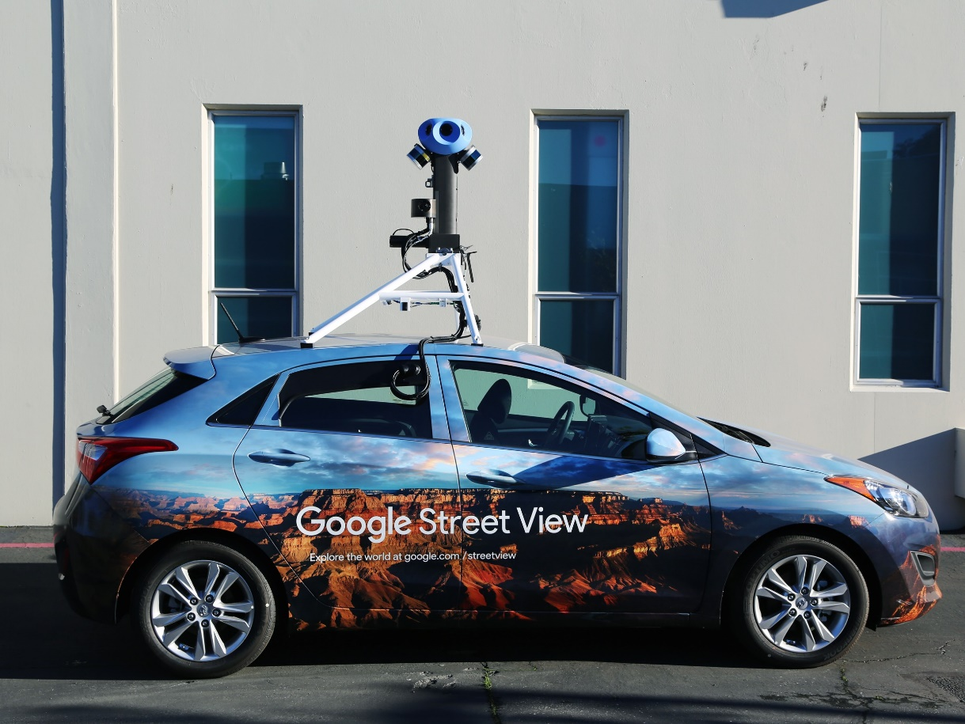
New territory
Decoding Street View imagery with algorithms can be especially useful in places where roads, cities, and businesses are changing fastest—the less-developed economies where Google and its competitors hope to find their next few billion users. The government of India reported this year that it has recently laid an average of 14 miles of new road every day. Street View went live this summer in Nigerian megacity Lagos—population 21 million. Fitzpatrick says that Google’s image-scouring algorithms could help translate the new imagery into a significant bump in map quality. Google sells ads inside maps, so new coverage and accuracy can translate into more revenue if they draw new users and usage to the service.
Google wants you to help feed its image-hungry algorithms. The tech industry’s recent interest in virtual reality has made 360 degree cameras relatively cheap. This summer, Google began certifying some cameras as “Street View ready,” meaning you can upload your own panoramas through the Street View mobile app to live on the company’s service. That footage will be processed by Google’s image recognition algorithms for fresh map data just like its own imagery.
Google is counting on crowdsourcing to make Street View data fresher than it is now. “The expectation is that Google has the world indexed,” says Charles Armstrong, a product manager for Street View. “But it never lives up to expectations.” Google’s Street View mobile app rewards individuals who contribute photos with virtual trophies, and it will even suggest local spots to take your camera. More significantly, Armstrong predicts companies, tourist boards, and even governments will soon be driving their own camera-toting cars to make sure the world gets an up-to-date view of their streets and cities.
All the upgrades to Street View could help Google maintain its prime position in digital maps. The company is the most prominent among the handful of leading global mapping projects. The other heavy hitters are HERE, owned by a coalition of German auto companies; TomTom, known for stand-alone GPS units and watches; and collaborative project Open Street Map. “Each one measures themselves against the others,” says Alyssa Wright, president of the US chapter of Open Street Map. (Apple’s relatively young mapping operation licenses data from TomTom.) In a world where most of us carry GPS-equipped smartphones, maps data is important for much more than just directions. “Mapping is fundamental to how we build our digital future, from autonomous vehicles to dating apps,” says Wright.
Street View’s new cameras and Google’s push for crowdsourced imagery could also lead the company into new privacy controversies. Concern about Google making ephemeral public scenes into permanent internet fixtures has rumbled, and occasionally flared, since Street View began. Germany and Austria are largely invisible on Google Street View, and have been for years, after the company got in trouble for logging Wi-Fi data with Street View vehicles. Google's fleet only recently returned to both countries. In 2012, Switzerland’s highest court ordered Google to cut down its cameras to prevent them from peeping over walls and to blur certain places such as women’s shelters.
Fitzpatrick flicks away the suggestion that higher quality imagery could lead to more privacy concerns. “We haven’t seen or heard of places where there are additional sensitivities,” she says. Google will continue to automatically blur faces and license plates on its own Street View images. But it won’t do that by default on crowdsourced footage, instead leaving it up to users to choose whether to use Google’s blurring technology when they upload new 360 photos.
How much more could Google extract from Street View using image processing algorithms? A lot.
Earlier this year Stanford researchers, including professor Fei-Fei Li, now chief scientist at Google’s cloud division, showed they could predict income, race, and voting patterns for US cities with software that logs the make, model, and year of cars in Street View photos. When asked if anything like that was planned at Google, a spokesperson would say only that the company is always looking for ways to use Street View data to improve the company's platforms, including beyond maps.
Processing Street View images from Google and its users might also help the self-driving cars of fellow Alphabet subsidiary Waymo understand the world. “The team collaborates on things from time to time,” is all Fitzpatrick will say about that. But her team has as much to gain in return from Waymo.
Back in that Google parking lot, camera-wizard Silverman confesses that trolling highways in a Street View car sporting one of his team’s devices isn’t much fun. “After a day you’re ready to not be a bus driver and go back to engineering,” he says. Just as self-driving vehicles would shift the economics of on-demand ride services, not having to pay people to be bored behind the wheel would be a boon to Street View. The company’s algorithmic index of the physical world may just be getting started.
(https://www.wired.com/story/googles-new-street-view-cameras-will-help-algorithms-index-the-real-world/)

3. A Google Street View Image

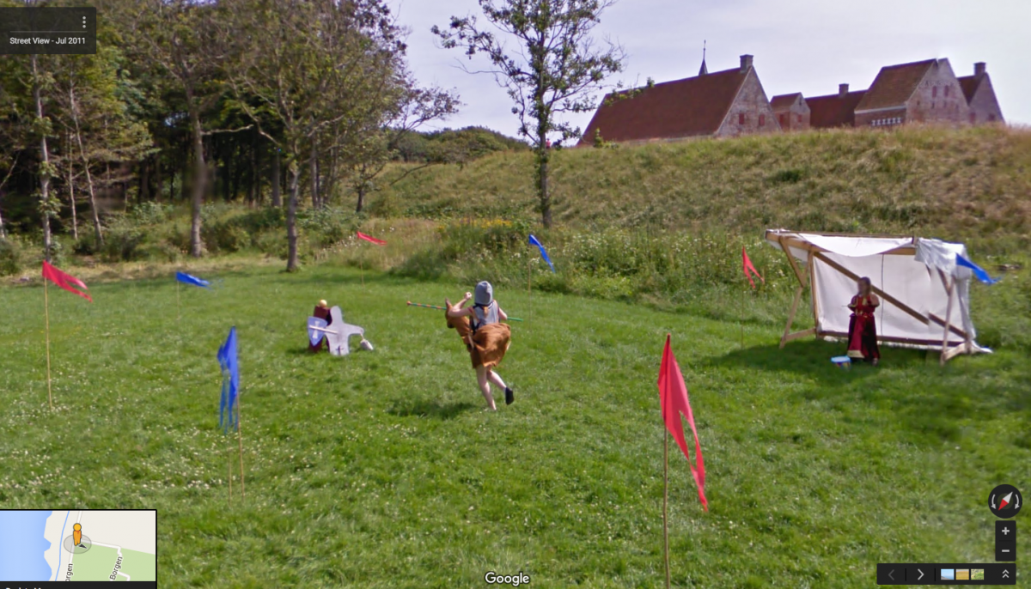
A young child jousts while another watches from the stands in Denmark.

4. Newspaper article
Google Street View causes stir in Botswana - Opposition paper in Botswana, the second African nation to get Street View, says images of military bases compromise security.
In cities around the world it has provoked grumbles about invasion of privacy and jeopardising national security – and has caught unsuspecting members of the public with their pants down. So when Google's Street View cameras came to Botswana, a country of 2 million people and 70% covered by the Kalahari desert, the company might have expected to avoid such controversy. Not so.
"We feel such places as the military base and the office of the president, the American embassy and any other such high-security areas should not have been allowed to be published," the Monitor newspaper opined in an editorial on Monday. "This compromises our security."
It went on: "What is also amazing is that prior to the shooting of the map, there was assurance that residential areas would be left out … but now these are in the Google map."
Government officials moved to dismiss the complaints as a storm in a teacup in an opposition-owned newspaper. Spokesman Jeff Ramsay said: "We don't have an issue at all. We had an internal debate because we recognise there are sensitivities but we are an open society.
"Google were working with our security people on a checklist of what to photograph and what not to photograph. If anything falls between the cracks, our people have a right to remove it."
He added: "Some reporters get Street View confused with Google Earth, which shows all sorts of things that we can't do anything about."
Google says it applies face-blurring and licence plate blurring to protect people's privacy in Street View. Once images are available, users can report images for removal by clicking on "report a problem" on the bottom left hand corner of the image.
Botswana is the second African country to be featured after its neighbour South Africa just before the 2010 football World Cup. Google deployed 4x4 vehicles to photograph difficult off-road areas.
The company said users could virtually explore the Kalahari and the world's biggest inland river delta – the 16,000 sq km Okavango – as well as the Makgadikgadi Pan and Chobe National Park, home to the biggest concentration of African elephants in the world.
The service, offering panoramic street-level images, is available in more than 30 countries. "We hope to add more cultures, landscapes and sites as Street View continues to expand to new places," said Ory Okolloh, policy manager for Google Sub-Saharan Africa. (https://www.theguardian.com/world/2012/dec/04/google-street-view-botswana)

5. Newspaper article

Our house, in the middle of Google's street. Is the latest addition to the search giant's mapping empire an infringement of our privacy or a public service?
So far launched in 27 American cities including New York, Los Angeles and San Francisco, Street View allows users to swoop down to pedestrian level and view a 360-degree photographic panorama of the buildings, roads and unfortunate passers-by caught in the eye of Google's vans. The site has inspired hundreds of thousands of "Street View Tourists" who participate in scavenger hunts, "celebrity crib spotting" and post advice on where to spot the vans that take the pictures for it. Househunters, too, have been able to explore potential neighbourhoods for local restaurants, supermarkets and schools.
But as bloggers trawl the site for the newest and most bizarre stills caught by Google's roving photographers, hundreds of Americans have complained, seeking to have more than just their faces removed. One couple, Aaron and Christine Boring of Pittsburgh, in Pennsylvania, have sued, claiming that the panoramic pictures of their residence, on a private road, have caused them "mental suffering" and diminished the property's value.
While Google does not preannounce its mapping strategy, it told the Guardian it will be focusing on "major metropolitan areas" and that it will "leave it to the imagination" whether London will be one of them. But although London has the dubious title of the most surveilled city in the world, and with more than 4.2m CCTV cameras in Britain, not everyone will welcome the Street View vans.
Simon Davies, director of surveillance watchdog Privacy International, confirmed it would be taking legal action as soon as Google began any Street View operations in the UK. "Google shouldn't be cavalier about that," Davies said. "I would predict we could stop Street View with one complaint. But Google has a messiah complex."
It's a strange embodiment for a messiah. Each Street View van has a roof camera, and photos - taken by 16 lenses - are stitched together to produce a 360-degree image. Immersive, the Canadian company that makes the Street Map cameras, says that while "spherical video" currently only collects photographic stills, its full-motion video capabilities could, in time, stream live footage. The latest version of Microsoft's Live Search Maps, a real-time satellite view, was launched last October, although it currently does not zoom close enough to capture people.
Mapping the cost
The vans map for five hours each day around noon; outside those times, the sun is too low in the sky to generate useful photos. (This may naturally limit how far into northern and southern latitudes at which Street View can be used.) At $45,000 (£22,000) per camera, and anything between $125 and $700 per mile of video footage, Google's mapping venture does not come cheap.
With such a huge investment already under way, Google has been keen to quieten its critics. "Street View only features imagery taken on public property and is not real time," it said in a statement. "This imagery is no different from what any person can readily capture or see walking down the street."
Both American and British privacy laws state that a person has no reasonable expectation of privacy in a public place. But recent CCTV guidelines, published by the Information Commissioner - which could apply to Street View - state that "signs should be placed so that the public are aware that they are entering a zone which is covered by surveillance equipment". This could prove impossible for Google's unmarked vans as they go about their task.
Legal forecast: stormy
In addition, under UK law, permission must be obtained before broadcasting images of private citizens. Google does have a service which allows unwitting "Street View celebrities", as they have become known in the blogosphere, to email requests to have themselves removed or their faces blurred. But Davies warns that publishing the images in the first place could be illegal. Worried pedestrians may also not know where to look for themselves. "You don't think of where you walk to work every day or where you were Friday night," says Rebecca Jescke, spokesperson for the Electronic Frontier Foundation, an internet civil rights group based in San Francisco. "Under US law what Google is doing is legal, but it doesn't mean it is very polite."
Street View has also raised national security concerns in the US. Last month, the Pentagon banned Google from making close-up images of military bases after it was revealed that pictures of the Fort Sam Houston army base in Texas included access control points and other potentially risky details.
But other sorts of security may be at risk. After what appeared to be a drug deal in central Chicago was broadcast over several blogs, the offending images were immediately removed. Last year, Californian Mary Kalin-Casey caused disquiet when she commented to technology site Boing Boing that she could spy her own cat, Monty, through her apartment window: she said she could even tell it was a tabby. If American audiences are anything to go by, the complaints will be louder than the compliments.

One result may be telling, though. The pictures of Aaron and Christine Borings' house have been removed from Street View. But will Britons choose to go down the same road?
(https://www.theguardian.com/technology/2008/apr/10/news.google)

6. Questions

1. What is Google Street View? When and where was it first launched?

2. How are the images taken for Street View?

3. Describe some of the key features of Google Street View.

4. Describe some of the places that Google Street View has recorded.

5. How has the Google Street view technology been developed in recent years? What are
some of the benefits of this? What are some of the issues?

6. Explain some of the issues that have surrounded Google Street View.
7. What are some of the ethical conflicts between Street View’s value as a service and its
potential impact on people?

8. Explain and defend how, as a Google project manager, you would evaluate a proposal to bring Google’s Street View technology to a remote African village.
What questions should be asked?
Who should be consulted?
What benefits, risks and safeguards should be considered?

