Topic: Theatre Sets
- Factsheet
Location – this is the ‘where’ of the set design. The design represents a place.
- For a “realist” set this might be a certain room, in a certain house, belonging to a certain character.
- The set designer will try to ensure that the audience understand this by placing specific objects and furniture into the space.
- The designer will also create appropriate scenery
- For “non-realist” sets, the location might be more difficult to decide.
- For example- the designer might create a location that combines a number of different places.
- Some designers want to make the audience aware that they are in a theatre as well as understanding that the action takes place in a specific location.
- Minimalist or symbolist designs do this particularly well.

Era – is the ‘when’ of the set design. When does the action take place?
- This might be the era in which the play is set
- It could also be another era that the director or designer has chosen for the production
- Designers don’t always stick rigidly to one era in their design. Sometimes it is useful to deliberately mix eras for a specific effect.

Style –Set designers work in a range of styles
- Realism
  - set designs incorporate elements that are meant to look like real life
  - can be total or partial
  - total realism means a set that looks as close to real life as possible and includes scenery, furniture and props that mimic a real-life setting. The design will reflect the period that the play is set in with historical accuracy.
  - Partial realism incorporates realistic elements into a set that might not be realistic overall. For example, using detailed period furniture on a stage constructed of a series of platforms.

- Symbolism
  - Symbolist sets are more interested in communicating an idea to the audience than it representing real life.
  - It allows the designers to choose an image that they think represents the key themes of the play and to interpret this as a stage set.

- Minimalism
  - Minimalists sets use pieces of stage furniture or props to indicate a setting or location.
  - Example: a table and two chairs could indicate a kitchen, dining room or a café.
  - The specific identity of the space is determined by the way in which the actors behave-this process if called minimal signification.
  - There are many small theatre spaces, for example black box theatres, that are well-suited to minimalism.

- Fantasy
  - Fantasy set designs allow the designer to create a new world for a production.
  - Designers can engage with fantastical locations without having to represent a world that the audience already knows
  - Fantastical design still needs to maintain an internal logic so that the audience can understand and engage with the production
Decisions the designer has to make:
- Shape
  - The shape of the stage floor, the shape of any platforms, levels or pieces of scenery.
  - The shape of any stage furniture.
  - Different shapes can have a different effect on the audience or create a different atmosphere
  - Lots of smooth curves look and feel very different to lots of jagged, pointed lines.
- Colour
  - The colours used on the stage floor, pieces of scenery, stage furniture and backdrop.
  - Colours on stage have many functions: they can be used to reflect colours in real life, create an atmosphere or tell an audience about the mood of a place or the personality of a character.
- Scale - The size of individual items on stage and the relationship between different objects of different sizes.
  - An audience can be told that an object is very important by making it slightly bigger and ‘out of scale’.
  - A strange atmosphere can be created by varying the scale of different parts of the stage.
- Texture - The textures of surfaces on the stage (the floor or the walls), as well as the texture of the stage furniture.
  - Texture comes from materials used to create the set (wood, metal, fabric) or it can be created using paint effects (for example, a painted woodgrain effect).
  - Different textures can give the audience information about the setting of the play (e.g. heavy velvet curtains hanging at a window can tell the audience that the character who lives here is very wealthy
  - Can help create an atmosphere on stage (i.e. shiny metal surfaces can give a set a cold and clinical feeling).
The Audience
Part of understanding a set design is understanding the effect of the set on an audience. Useful questions to consider are:
- End-on or proscenium arch theatres create a clear divide between actors and audience
- Thrust theatres partly surround the stage with the audience
- Theatres in-the-round entirely surround the stage with the audience.
- Traverse theatres have two blocks of audience facing each other across the stage space.
- Promenade theatre allows the audience to move freely around the performance space, often guided by the actors.
- Immersive theatre surrounds the audience with an experience, and thy often interact directly with the actors and the space.

Each of these configurations creates a different relationship between the actors, audience and performance space.
(Source: http://filestore.aqa.org.uk/resources/drama/AQA-7262-SET-D-TG.PDF)

Set Design for production of Hedda Gabler

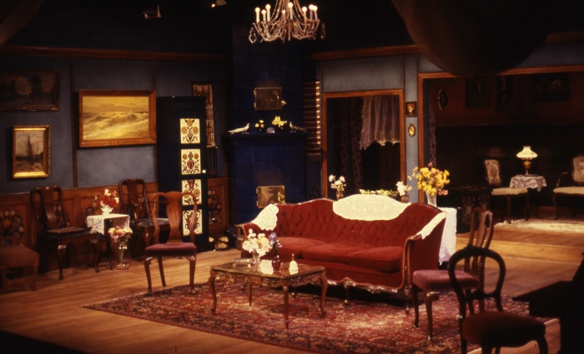

Set by Tina Kitzing for the Landesbuhne theatre in Hannover (1999)

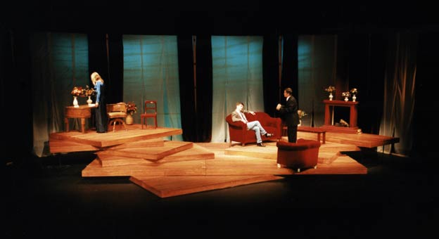

- The blue beyond the curtain seems to indicate the sky outside. The contrast between this blue and the warm yellows and reds make the room seem cosy.
- Kitzing uses natural textures like wood and muslin which give the room a natural, comfortable feel.
- The furniture is smart and high quality, indicating the social class of the characters.
- Kitzing has chosen furniture that is not from the period of Ibsen’s play (1890s), but from a mixture of eras. This could suggest that the production is set in the modern day. Mixing different eras can also make a play seem relevant to a lot of different times, a way of telling the audience that the play’s message is still important and relevant today.
- The wooden platform seems unstable. This is a deliberate choice by Kitzing to make the set feel like it might collapse at any moment. She believes that this reflects the unstable relationship that Hedda has with her husband, Tesman.
- The focus of the design is these piled up platforms. These give the actors a number of levels to work on.

What does Ibsen say about the set?

Here is Ibsen’s introduction to Act 1 of Hedda Gabler, which gives a detailed outline of the set. O’Mahony has interpreted this, selecting key items from Ibsen’s description, including the curtains, high-backed arm chair and oval table. Other items are suggested, but not realistically represented, for example the windows. The audience use their imaginations to ‘fill in the gaps’ in the design and O’Mahony’s set both indicates the era and location of Ibsen’s play and reminds the audience that they are in a theatre.
“A spacious, handsome, and tastefully furnished drawing room, decorated in dark colours. In the back, a wide doorway with curtains drawn back, leading into a smaller room decorated in the same style as the drawing room. In the right-hand wall of the front room, a folding door leading out to the hall. In the opposite wall, on the left, a glass door, also with curtains drawn back. Through the panes can be seen part of a verandah outside, and trees covered with autumn foliage. An oval table, with a cover on it, and surrounded by chairs, stands well forward. In front, by the wall on the right, a wide stove of dark porcelain, a high-backed arm-chair, a cushioned foot-rest, and two footstools. A settee, with a small round table in front of it, fills the upper right-hand corner. In front, on the left, a little way from the wall, a sofa. Further back than the glass door, a piano. On either side of the doorway at the back a whatnot with terra-cotta and majolica ornaments. Against the back wall of the inner room a sofa, with a table, and one or two chairs. Over the sofa hangs the portrait of a handsome elderly man in a General's uniform. Over the table a hanging lamp, with an opal glass shade. A number of bouquets are arranged about the drawing-room, in vases and glasses. Others lie upon the tables. The floors in both rooms are covered with thick carpets.”

5. Questions
1. What are the main factors a designer has to think about when designing a theatre set?

2. Describe the difference between a realist and non-realist theatre set.

3. Describe two of the styles a set designer might use.

4. How can theatre sets create different relationships between the actors and the audience?

5. How does Ibsen describe the set for his play Hedda Gabler?

6. How are O’Mahony’s and Kitzing’s designs similar? How do their designs communicate different things about the Ibsen’s play? Which do you find most effective and why?

7. Look at the image of the set design for Hedda Gabler.
What style is the set in? How can you tell? What colours has the designer used? What effects do these colours have? What era is the furniture? What does the set tell you about the social class of the characters?

8. How closely does the set reflect Ibsen’s notes in the play text? What has the designer chosen to include or leave out? Why might this be?

9. What textures has the designer used? Is the designer using any specific shapes? What atmosphere has the designer created?

