Topic: Meeting Point by Louis MacNeice

Fact Sheet
- Louis MacNeice (1907 – 1963) was born in Belfast. He was educated in England and read classics at Oxford University where he met his wife, Giovanna.
- Following his graduation he worked as a lecturer, before joining the BBC as a writer and producer for radio.
- Six years after their marriage, his wife divorced him, leaving him as the single-parent of their son.
- Early in his career, MacNeice was identified with a group of left-wing poets known as the ‘Auden Group’. Though he was politically aware, and often wrote on the topic of politics, he himself expressed scepticism of political groups and the attitudes championed by the Auden Group.
- Although he lived in London for most of his adult life, MacNeice took pride in his Irish heritage, returning to his childhood home many times, and referring to Northern Ireland in many of his poems.
- His work is colloquial and often ironic, combining humour and tragedy in tackling issues of the time.
Meeting Point
- Meeting Point is about a couple sitting in a coffee shop. Time appears to be standing still, because they have just realised that they are in love. The Meeting Point is both literal and metaphorical: it is both the coffee shop and the place at which their hearts meet. The real world, symbolised by various things, stops, and becomes irrelevant because they are in love.
Form and Structure
- Meeting Point is written in an original form. Each five line stanza has the first line repeated as the last line. They rhyme with the middle line of the stanza, while the second and fourth lines also rhyme, so that the rhyme scheme is ABABA. The repetition of the lines emphasises the central idea of the poem – that time is standing still for the couple. Similarly the repeated line from the third stanza becomes the middle line of the final verse.
- The first line is used again as the repeated line in the fifth stanza, and a modified version is used for the final stanza, altered to focus on the woman. This creates a circular structure to the poem, which also emphasises the idea of the moment seeming to last forever.
Language and Imagery
- Throughout the poem there is recurring imagery related to time. As well as multiple references to clocks or bells (used to chime the hours) there are more complicated images.
- In the fourth stanza the coffee shop becomes a desert, in which the distance they travel and the stars become a measure of time, which they can divide up themselves, giving them some power over time. (There is also a pun in this stanza – are the dates the type that you get in a calendar or ones that you can eat?)
- Similarly, in the next stanza, the simile that shows the music coming out of the radio so slowly that it might not be coming out at all, suggests the way that everyday life is slowing because they have realised their love. The fact that it is still coming out, however, shows that time cannot be stopped completely, which is a key theme in MacNeice’s other work.
- The mingling of the everyday surroundings and the natural imagery suggests the permanence of love and how it underlies everything. This mingling goes on between and within verses, so that the stock-market is linked to rain-forests. The allusion to God in the seventh stanza also elevates the importance of love.
Sound
- In the third stanza the sound of a bell is created through the repetition in the middle line.
Attitudes, themes and ideas
- Love is the main theme of the poem, and specifically the moment at which a couple discovers that they are in love. At this point, it seems that the two people become one, with just one heartbeat, and everything else in the world fades away.
- Another key idea in the poem is time, shown in the huge variety of images and symbols in which it is represented. Although it seems to be stopped in the moment of the poem, there is a suggestion in the simile in the fifth verse that it is still going on, ever so slowly. This suggests that even something as powerful as love is not powerful enough to stop time.
- In the final stanza the focus changes slightly and the repeated line focuses on the woman. You could argue from this that the whole poem is from her point of view, and that it is her realisation that has been described in the poem, so love is more important for women. Alternatively, you could argue that this use of the feminine pronoun ‘she’, together with the focus on her fingers in the sixth stanza, actually show it is from the man’s perspective. He is watching her, and it is his realisation that the poem describes.

Meeting Point, By Louis MacNeice

Time was away and somewhere else,
There were two glasses and two chairs
And two people with the one pulse
(Somebody stopped the moving stairs):
Time was away and somewhere else.

And they were neither up nor down;
The stream’s music did not stop
Flowing through heather, limpid brown,
Although they sat in a coffee shop
And they were neither up nor down.

The bell was silent in the air
Holding its inverted poise—
Between the clang and clang a flower,
A brazen calyx of no noise:
The bell was silent in the air.

The camels crossed the miles of sand
That stretched around the cups and plates;
The desert was their own, they planned
To portion out the stars and dates:
The camels crossed the miles of sand.

Time was away and somewhere else.
The waiter did not come, the clock
Forgot them and the radio waltz
Came out like water from a rock:
Time was away and somewhere else.

Her fingers flicked away the ash
That bloomed again in tropic trees:
Not caring if the markets crash
When they had forests such as these,
Her fingers flicked away the ash.

God or whatever means the Good
Be praised that time can stop like this,
That what the heart has understood
Can verify in the body’s peace
God or whatever means the Good.

Time was away and she was here
And life no longer what it was,
The bell was silent in the air
And all the room one glow because
Time was away and she was here.

Louis MacNeice, “Meeting Point” from The Collected Poems of Louis MacNeice. Copyright © 1967 by Louis MacNeice. Reprinted by permission of David Higham Associates, Ltd.
Source: The Collected Poems of Louis MacNeice (Oxford University Press, 1967)

Image
‘The waiter did not come, the clock/forgot them’…a young couple sit by the window of a café.
Photograph: John Murray/Getty Images
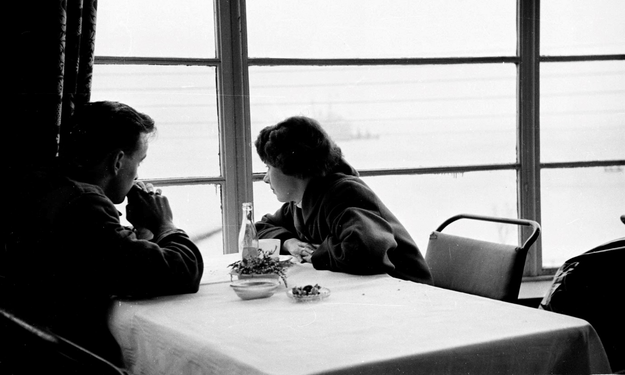

Meeting Point by Louis MacNeice
Written in a time of ever greater division, this beguiling love poem celebrates two lovers’ almost mystical union.
Meeting Point is a love poem poised at a high pitch of communion and entrancement. It marries various literary devices – narrative and song, realism and fantasy. The form is unusual, making first and last lines each five-lined stanza’s refrain. This device completes a circle each time, and almost uncannily brings the reader into the physical experience of the story. Frequent comma splice and enjambment are offset by well-judged colons and halts: this is a complex dance of a poem, perhaps a polka rather than a waltz.
Everything is orderly yet liminal, and even miraculous. “Time was away and somewhere else”, “And they were neither up nor down”, “The bell was silent in the air”, and so on. The first refrain-pair recurs in the fifth stanza, and comes back a third, final time with a new twist: “Time was away and she was here.” Designedly simple, almost artless, it’s the perfect climax of a poem that has all the while been gently spinning in accumulating narrative arcs to reach the still point where mimesis gives way to original presence.
MacNeice made one revision when reprinting the poem in Eighty-Five Poems (1959): he changed the penultimate line from “And all the room a glow…” to “And all the room one glow…” Peter McDonald acknowledges the revision as an improvement, but scrupulously restores the earlier line, as printed in The Last Ditch. But the truth is, any impression of a flaw here is the reader’s problem, not the poet’s. We may need a quick rethink to avoid confusing “a glow” with “aglow” – which would certainly be dated and sentimental – but, when we read the line properly, the indefinite article works fine, and seems more appropriate to the evanescent mystery of it all than the emphatic “one”.
This could almost be another of MacNeice’s travel poems, only the country travelled is rendered surreal (as in the super-real) by a sort of double exposure. There is the stream and the heather, transplanted from Ireland, perhaps, a desert made lustrous with “the stars and dates” of which the lovers (not, I think, the camels) have control, the miracles of “water from a rock” and cigarette ash reformed as blossom in forests of “tropic trees”. At the same time, the couple never leaves the coffee shop, and we are constantly reminded of the immediate and ordinary environment of cups and plates and waiters.
WH Auden’s The Fall of Rome seems mirrored in stanza four’s image of camels crossing “the miles of sand”. And there’s another Auden poem, less directly recalled but present in stanza seven, Lullaby. Auden’s speaker reflects on the ethical nature of “the vision Venus sends” the post-coital lovers. MacNeice, more of a sceptic than his friend, nevertheless allows the erotic vision to impress a mystical gravity on his narrator with the realisation: “That what the heart has understood / Can verify in the body’s peace / God or whatever means the Good.” The refrain finds a solution to doubt; even while it owns the difficult honesty of agnosticism, it declares the centrality of sexual love to “verify” human constructions of “the good” – whether or not that construction is called God.
Coexisting with this vision of wholeness, something dangerous has to be kept at bay. The lovers’ timeless circles are unreal and impossible to secure. Like much of the collection, Meeting Point is pervaded by eve-of-battle delirium, expressed in restless movement and return, and scenes that are intrinsically fluid despite the superb technical control. This is a love poem (and lullaby?) written in 1939. Its dance, in part, is the protest of the organic and organising imagination against the chaos of approaching war.

(Source: Carol Rumens, www.guardian.com)

Questions
1. What is the title of the poem? Who wrote it and when? What is a common theme of his work?

2. Describe in your own words what the poem is about.
(e.g. what is the main theme?)

3. What evidence is there in the poem that this is about love? List all the clues you can find and add a brief explanation for each

4. How is the title of the poem both literal and metaphorical?

5. In what sense is the poem written from an outsider’s perspective, even though it is recounting an intimate experience?

6. Remembering that the poem was written in 1939, pick out references in the poem to its contemporary setting, modern ideas and current issues. In what way could it be seen as a ‘reaction against darkness’?

Think about the social situation – what ‘dark’ thing happened to MacNeice? Think about the historical context: what was the political situation in 1939? How is this reflected in the poem?

7. How does MacNeice write the poem in a way that emphasizes the impression of this moment lasting forever?
Think about:
- Structure
- Language and Imagery

8. What does Carol Rumens mean when she says the “this is a complex dance of a poem”?
How does she liken it to a travel poem?
What does she think is the “something dangerous” that has to be kept at bay?

