Topic: Water

Fact Sheet
The Geography of Water Supply
- Water is vital to human survival and is needed for a range of different activities.
- Freshwater is a finite resource which means is a fundamental issue for water supply.
- Only a small percentage (2.5%) of global water is freshwater and therefore suitable for most human uses.
Trends in water demand:
- The demands being placed on water are increasing all the time.
- There is a widespread mismatch between the distributions of water availability (supply) and water demand.
- This mismatch is responsible for the creation of areas of water stress and water scarcity.
- Global demand for water will continue to rise due to:
- Increasing population – more people, so more thirsts to quench
- Economic development – greater use of water in farming and industry
- Rising Living Standards – more water wanted in the home for washing, cleaning etc.
- The rate of increase in water demand is likely to be high in developing countries as they industrialise and become more urbanised.
- In developed countries, water demand is less likely to increase much.
Water Management Strategies
- Managing future water supplies requires actions at a variety of levels. These range from large-scale projects funded by governments and international agencies, down to the local level of changing individual consumers’ attitudes to water use.
- Large-scale water management projects involve hard-engineering and include;
  - The collection of surface freshwater by means of mega-dams and storing it in reservoirs – at present, two-thirds of all surface freshwater is abstracted in this way
  - Long-distance water transfer schemes, such as those that are now under way in China, Brazil and Spain.
  - Desalinisation, which makes drinkable freshwater from salty seawater. It is relatively new, but much is now being done in water-stressed but technologically-advanced countries such as the Middle Eastern states, Japan and USA.
  - Restoring Wetlands so that they can once again act as vital water stores.

Water transfer schemes
- A particular feature of water supply is the transfer of great quantities of water, often over considerable distances.

- This is necessary where there is a mismatch between the distributions of water availability and water demand.

- Water surpluses have to be transferred to those areas where the level of water demand creates water deficits.

- The pipelines and canals used in this transfer of water are water pathways.

- There are different approaches to managing water supply, some are more sustainable than others.

- Examples of large-scale water transfer schemes include:

        - The Tagus-Segura Scheme in Spain
        - The Snowy Mountains scheme in South-East Australia
        - The South to North Project in China

- Water transfer schemes require much investment and engineering.
- They are only undertaken if there are considerable benefits.
- However, there are costs for both the source and receiving areas, as well as the areas in between.
Costs include:
- Adverse environmental impacts of the water transfer infrastructure, for example, the construction of dams and reservoirs, pumping stations, pipelines and canals.
- The possibility of water scarcity in the source area due to loss of available water
- A greater and more wasteful use of water because of the increased availability of water in the receiving area, e.g. more irrigation, more golf courses, more water sports facilities
- Pipelines being vulnerable to sabotage and terrorist attacks.

Desalination

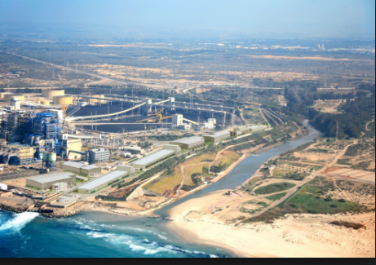

Sorek Desalination Plant

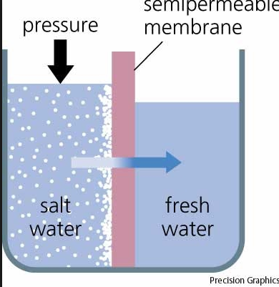
Desalination works by pushing saltwater into membranes containing microscopic pores. The water gets through, while the larger salt molecules are left behind.

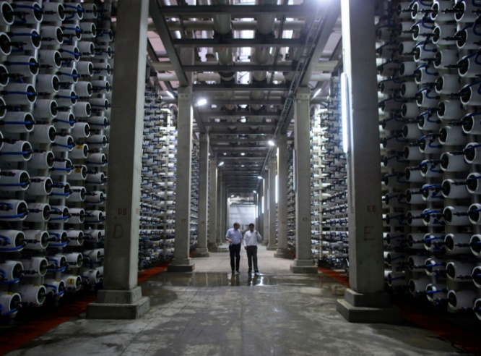

Israel has developed a chemical-free system using porous lava stone to capture the microorganisms before they reach the membranes

Will Ethiopia’s Grand Renaissance Dam dry the Nile in Egypt?
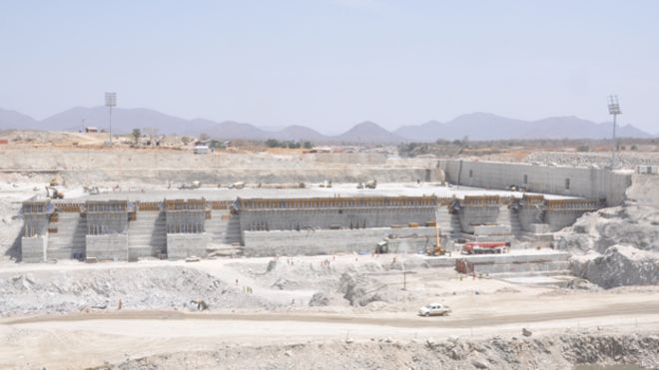
Ethiopia is pressing ahead with construction of a major new dam on the River Nile, despite stiff opposition from Egypt. BBC correspondents in both countries report from both sides of an increasingly bitter water dispute.
Emmanuel Igunza, Ethiopia
A vast section of northern Ethiopia has been turned into a giant building site.
Construction of the Grand Ethiopian Renaissance Dam (known as Gerd) is now about 30% complete.
The whole project spans an area of 1,800 sq km (695 sq miles).
Once completed, in three years, it will be Africa's largest hydropower dam, standing some 170m (558ft) tall.
At a cost of $4.7bn (£2.9bn) it will also be hugely expensive - mostly funded by Ethiopian bonds and taxpayers.
The dam is located in the Benishangul region, a vast, arid land on the border with Sudan, some 900km north-west of the capital Addis Ababa,
Temperatures here can get as high as 48C (118F). Most of the vegetation that existed on the dam site has been cleared to make way for the construction, and the area is now extremely dusty.
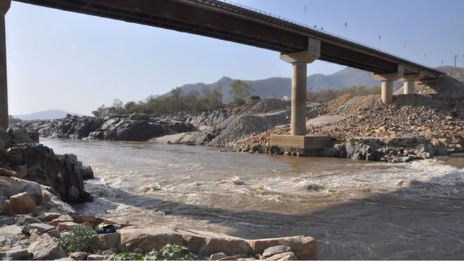
In May last year, the builders achieved their first milestone when they diverted the course of the Blue Nile.
What used to be the river bed is now being lined with layers and layers of concrete that will form part of the main dam.
Some 8,500 people working at the site, where construction carries on 24 hours a day.
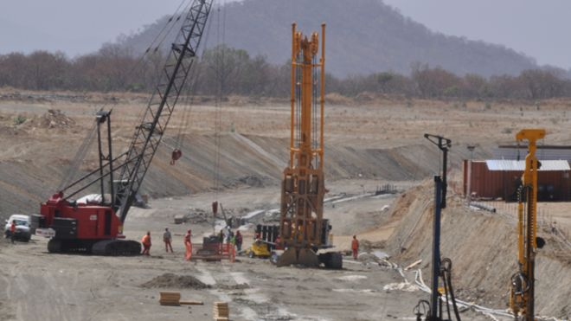
Part of the actual dam structure is already taking shape. The workers are busy at work on what looks like a huge floor of concrete.
Downstream, Egypt - which relies almost totally on the waters of the Nile, says their supply will be under threat.
Egypt and Sudan currently get the lion's share of the Nile's waters under colonial-era treaties. While Sudan backs Ethiopia's plans, Egypt has remained opposed.
Talks to ease tensions between the two countries have collapsed.
Despite this, Ethiopian foreign ministry spokesman Amb Dina Mufti describes the dam as a "win-win" project.
"Sudan has already seen the benefits and has come on board, we hope Egypt will see that too," he says.
Sally Nabil, Aswan, Egypt
The concern in Egypt is about the potential threat to its dominance over the Nile.
Egypt fears Ethiopia's dam will restrict the flow of this strategic waterway - the main source of water in a country where rainfall is scarce.
The row started in 2011, and Egypt has been worried ever since that its annual quota of the Nile water might be reduced.
This conflict comes at a time when different parts of Egypt are already suffering from a shortage of water. In the northern Nile Delta, the agricultural heart of Egypt, a lot of farmers are waiting with a heavy heart to see if they will be able to cultivate their land next summer.
"With even less water, we will die. We can't survive," says Hafiza, one of the farmers.
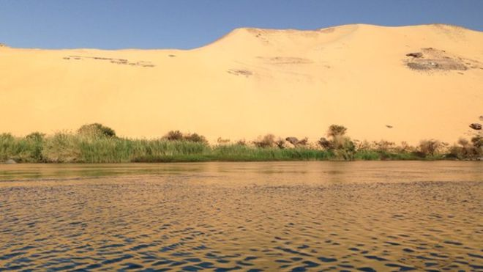
Ethiopia says its hydro-electric dam will not harm either of its downstream countries, Egypt or Sudan. However, Egypt is highly sceptical.
"It is a matter of life or death, a national security issue that can never be compromised on," says foreign ministry spokesman Badr Abdelatty.
Egypt is aware that some 30% of the Ethiopian dam is completed. It is still unclear what Egypt's next step will be.
(https://www.bbc.co.uk/news/world-africa-26679225, 22/03/2014)

Case Study: Water Transfers in China
China’s water diversion project starts to flow to Beijing
£48bn scheme may provide relief to the parched north, but at what cost to the drought-ridden south and its displaced farmers?
On Friday afternoon, China quietly inaugurated one of the biggest engineering projects of all time: the South-North Water Diversion, a £48bn, 2,400km network of canals and tunnels, designed to divert 44.8bn cubic metres of water annually from China’s humid south to its parched, industrialised north.
At 2.32pm, the project’s “middle line” officially began carrying water from the Danjiangkou reservoir in central China’s Hubei province to Beijing – the distance from Corsica to London. The project, officials say, will save China from a water crisis that could set its development back years.
It has also destroyed Wang Yanhe’s life. Wang was born near the Danjiangkou reservoir in 1979, married young and had two children – the family lived between a small stream and a leafy hillside, and grew a variety of grains. In 2009, seven years after the project was approved, officials informed him that the reservoir’s water levels were rising and that his village would be submerged. About 345,000 villagers have been displaced by the project to date, and Wang soon became one of them. The government gave him a home in the Heba New Migrant Village by a dusty highway in rural Pingdingshan, a coal-rich municipality in neighbouring Henan province whose name translates to “flat mountain”.
Then came the drought. This summer was Pingdingshan’s driest in 63 years – Wang’s corn crop only grew to knee-height, forcing him to abandon his harvest. “Nothing is as good as before,” he said, chain-smoking cigarettes in his concrete-floored living room. His roof leaks; he can’t speak the local dialect. Officials promised him 0.2 acres of land, but only gave him 0.15. “After we arrived, we realised that the land was all dry,” he said. “So it doesn’t even matter what they promised us.”
The Henan Daily newspaper announced the line’s inauguration in a pithy microblog post on Friday. “Being a peoples’ engineering project, in keeping with a frugal and pragmatic working style, celebratory activities will be kept as simple as possible,” it said. “No officials will take part in the ceremonies.”
China’s booming economy over the past three decades, coupled with a long-held mandate to “grow first, clean up later”, has been cataclysmic for the country’s once-bountiful lakes, rivers and aquifers. More than half of China’s 50,000 rivers have vanished over the past two decades, according to China’s first national census of water, published last year. About 70% of its remaining fresh water is polluted. “If we continue with our business-as-usual model, China will basically run out of water,” said Feng Hu, a water analyst with the Hong Kong-based research group China Water Risk. “It won’t have enough water to power its economy.”
The project has roots in an offhand comment by Mao Zedong who, on an inspection tour in the early 1950s, said: “The south has plenty of water, but the north is dry. If we could borrow some, that would be good.” The project has three sections: a 1,150km eastern line, which runs from the lower Yangtze River to Tianjin; the middle line, from Danjiangkou to Beijing; and a western line, which could some day link the headwaters of the Yangtze and Yellow rivers across the high-altitude Qinghai-Tibetan Plateau. The eastern line began delivering water to coastal Shandong province last winter. The western line remains largely conceptual, so grand in scale that it may ultimately prove impossible to build.
While the project could provide some much-needed relief, it “will never solve north China’s water problem”, said Jennifer Turner, director of the China Environment Forum at the Wilson Center in Washington DC. She called the project a “Band-Aid” rather than a long-term solution. “The challenge in the water sector, writ large, is that it is so hooked into supply-side management,” she said. “It’s like the engineers in China have a special tattoo that says ‘nothing is too big’ – they’ll move water massive distances rather than get deep and dirty into the mess of pushing effective water conservation.”
In February, Qiu Baoxing, vice-minister of the Ministry of Housing and Urban-Rural Development, called the project unsustainable. “As the scale of the project gets bigger and the distance gets longer, it is more and more difficult to divert water,” he wrote. “Recycled water could replace diverted water. Most Chinese cities are capable of finding more water if we develop water desalination technology and collect more rain water.”
Experts say the south may no longer have enough water to spare. They say the project could decimate the Han River, an important tributary of the Yangtze – about 40% of the river’s water will eventually be diverted north, despite acute water shortages that already plague the cities along its banks. In 2011, five months of drought in Hubei province left 315,000 people short of drinking water. The Danjiangkou reservoir dropped to four metres below “dead water” level, rendering it unusable. Speculation that the South-North Water Diversion project caused this year’s drought grew so heated that state media issued a denial. “Henan province is the recipient of benefits from the [project],” Yang Biantong, a spokesman for Henan’s flood control and drought relief department, told the People’s Daily in late August. “Not only has it not had a negative effect, the [project] has also been extremely helpful.”
Christine Boyle, founder of Blue Horizon Insight and an expert on China’s water issues, said the issue boils down to how one defines a drought. In addition to crippling weather droughts – periods of little rainfall – China is also suffering from economic droughts, which occur when the demand for water outstrips supply. “You can’t say the South-North Water Diversion is causing a weather drought,” she said. “But you can say it’s intensifying an economic drought.” Many Chinese farmers are already economically squeezed, and increasingly erratic weather patterns, perhaps related to climate change – freezing winters, blistering summers, floods and droughts – are now pushing them into a state of emergency.
The South-North Water Diversion project began sending emergency water supplies to Pingdingshan in mid-August and, according to the official newswire Xinhua, the diversion was a success. The middle line delivered more than 50m cubic metres of water to the city’s Baiguishan reservoir over a month and a half, it said, “effectively relieving the scarce water supply of Pingdingshan city’s one million-plus residents”.
While that water has flowed into the taps of Pingdingshan’s urbanites and the cooling systems of its coal-fired power plants, farmers on the city outskirts have been left to fend for themselves. Chang Xiangdang, 40, lives with his family of six in Malou Village, population 1,000, a dense cluster of cinderblock houses only a few hundred metres from the project’s main channel. From his small patch of radish and cabbage, high concrete embankments stretch to the horizon and an arch-like sluice rises like a mirage. “The channel runs through our town, but there’s no way to get the water, no gap in the wall,” he said. Villagers rely on groundwater for bathing and cooking. In previous years, they could dig 20 metres to reach the aquifer. This year, even 80-metre wells are running dry.

Chang said the lack of water has thrown his life into flux. Like Wang, the displaced farmer, he has given up on this year’s corn harvest. His family has been subsisting on a compensation package that project officials gave him four years ago, when they requisitioned much of his farmland. Another dry summer, he says, would leave him destitute. He has considered taking a construction job in the city. “There’s no more water here,” he said. “I’ll do what it takes to survive.”
(Jonathan Kaiman,https://www.theguardian.com/world/2014/dec/12/china-water-diversion-project-beijing-displaced-farmers 12/12/2014)

Questions
1. What are the main factors affecting the rise in the global demand for water?

2. What are the three ways that water shortage can be tackled?

3. Describe what a water transfer scheme is. Give an example of where this has been used.

4. What are the risk associated with water transfer schemes? What are the main environmental costs of large-scale water transfer schemes?

5. Describe and explain the pros and cons of the water transfer scheme in China.

6. Why has the Grand Ethiopian Dam been built?
Who benefits from its completion?

7. What is the current agreement between the two countries?
Why does Egypt object?

8. What is desalination?

9. Do you think desalination is a viable option for every country facing water stress? Use evidence to support your answer.

