Financial Guide for

Graduate Students

2022 Entry

Wadham College

PLEASE NOTE:
The information in this guide is intended for students commencing their studies in 2022/23 and is correct as at July 2022. For the latest information, for both new and returning students, please visit www.ox.ac.uk/students/fees-funding

CONTENTS

- What does it cost and how do I pay?
  - Course Fees
  - Battels

- What financial support is available to help fund my studies?
  - US and Canadian Loans
  - College Funds
  - Scholarships

- Targeted funding and extra support
  - Students with children or dependents
  - Students with disabilities

- Hardship funding
  - For students in financial difficulty
  - Oxford hardship funding
  - College hardship funding
  - Hardship funding for students impacted by the Coronavirus pandemic

- What happens if…
  - …I live out in privately rented accommodation.?
  - …I want to seek employment to support my studies.?
  - …I take longer than anticipated to complete my course?

- Money management
  - Budgeting
  - Student bank accounts
  - Employment and tax
  - Student discounts
  - Paperwork

- Valuables and Insurance
  - Risk and Liability

  - Insurance

- Useful contact details

WHAT DOES IT COST AND HOW DO I PAY?

COURSE FEES

For fees purposes graduate students are classed as Home, Islands or Overseas. Your classification depends on your nationality and certain residence conditions, and the definitions used by the University are given in Appendix I of the Examination Regulations. If you are unsure of your classification more details are available at https://www.ox.ac.uk/admissions/graduate/fees-and- funding/fees-and-other-charges/fees.

Course fees will usually increase annually and in deciding the annual level of increase, the University will take into account a range of factors, including rises in the costs of delivering the Programme. You can read further information on these annual increases on the University website at https://www.ox.ac.uk/admissions/graduate/fees-and-funding/fees-and-other-charges/changes- to-fees-and-costs.

HOW DO I PAY?
The invoices for course fees are distributed via email and are normally available by 0th week of Michaelmas Term (Freshers’ Week). Course fees can either be paid at the start of the academic year or in three termly instalments by Friday of 1st week (except for those reading for the BCL, Diploma in Legal Studies or the MJur, who must pay all course fees at the start of the year).

PAYMENT METHODS
Payments may be made by bank transfer, debit card, or over the Internet using an electronic payment facility. No charge is made for payments by debit card.

Bank Name: BARCLAYS BANK plc, Oxford City Sort Code: 20-65-26
Acc Name: WADHAM COLLEGE GENERAL ACCOUNT Acc No: 93631990
SWIFT/BIC: BARCGB22

IBAN: GB16 BARC 2065 2693 6319 90

Please ensure that the student’s last name and student number are quoted as part of the reference. Please also note that any transfer or currency exchange charges are the individual student’s responsibility.

WHEN DO I NEED TO PAY BY?
As stated in Appendix I, Regulations on Financial Matters of the current Examination Regulations available at https://www.admin.ox.ac.uk/examregs/, ‘The Annual University fees shall be paid on or before the seventh day of Michaelmas Full Term’. Please ensure that if you are liable for the payment of your fees, you have paid them by Friday 15 October 2022.

WHAT HAPPENS IF I DON’T PAY?
If you have not paid your course fees in full by Friday 15 October 2022, and you have not made an agreement with the College to pay in instalments, you are liable for suspension from access to the premises and facilities of the University. You will be notified of your liability for suspension and from the notification date you have a further four weeks in which to pay your fees. If within that time period you do not make arrangements to pay your fees in full or in instalments, you will be suspended until such a time as your fees have been paid.

BATTELS

Battels are bills sent to college members at the start of each term, listing the charges payable to the college. Depending on your circumstances, your battels can cover accommodation and catering charges for the coming term. They can also include charges or credits for other services from the previous term and vacation, such as vacation residence, college meals, MCR fees, photocopying and other small charges. The first battels of the academic year is sent in Michaelmas Term and will be in addition to course fees if you are liable to pay these. NB: BATTELS and FEES are separate accounts; one is titled FEES and the other is titled BATTELS.

HOW AM I INVOICED AND HOW AND WHEN DO I PAY?
Your Battels Statement will be sent to your College email inbox during minus 1st Week of Michaelmas Term and 0th week of Hilary and Trinity Terms. Payment is due by the Friday of 1st Week.

Payments may be made by bank transfer, debit card, or over the Internet using an electronic payment facility. No charge is made for payments by debit card.

Account details as given in 1.1.2.

WHAT HAPPENS IF I DON’T PAY?
Interest may be charged on a weekly basis on outstanding balances.

WHAT FINANCIAL SUPPORT IS AVAILABLE TO HELP FUND MY STUDIES?

US AND CANADIAN LOANS
Loan funding is normally dependent on your country of residence, as it is often linked to government or state-run schemes, so you should contact your local education authority or your government's Department of Education for more information. Also see:

https://www.ox.ac.uk/admissions/graduate/fees-and-funding/loans/other-loans?wssl=1

US and Canadian federal student loans are administered centrally by the University’s US Loans team. The University of Oxford is eligible to certify loan applications for the US Direct Loan Program. US and Canadian students wishing to take out a federal student loan must read through the information pages on the University website before starting the application process. For further information see:

www.graduate.ox.ac.uk/usloans www.ox.ac.uk/admissions/graduate/fees-and-funding/loans/other-loans

If you have further enquiries about the application process, the administration of loans, or any loan you have taken out, please contact us.loans@admin.ox.ac.uk

COLLEGE FUNDS
Wadham College has a number of funds that support small scholarships, prizes and grants. Information about these, including application procedures, can be found on the College website:

https://www.wadham.ox.ac.uk/students/graduate-students/graduate-finance/graduate- achievements-and-prizes

https://www.wadham.ox.ac.uk/students/graduate-students/graduate-finance

SCHOLARSHIPS
The vast majority of substantive scholarships available at Oxford are awarded as part of the admissions process, and therefore students are very unlikely to be awarded scholarships that would make a significant contribution towards their fees or living costs after they have arrived. There are a small number of scholarships for which students already on course can apply, although in the majority of cases a successful applicant would have to move to a different college in order to take up the offer of such a scholarship. Details of such scholarships can be found using the University’s Fees, Funding and Scholarship Search:

https://www.ox.ac.uk/admissions/graduate/fees-and-funding/fees-funding-and-scholarship-search

TARGETED FUNDING AND EXTRA SUPPORT

STUDENTS WITH CHILDREN OR DEPENDANTS

If you have dependents (a partner or child) or live with other family members, you will need to take into consideration the increased costs of childcare provision, food, clothing etc. More information and advice is available from the living costs page at www.ox.ac.uk/students/fees-funding/living- costs. A number of additional sources of childcare funding are available; for further details, including eligibility criteria, visit www.admin.ox.ac.uk/childcare/feesandfunding.

STUDENTS WITH DISABILITIES

Students with disabilities should contact the University’s Disability Advisory Service for information on any funding available. Contact details and more information about the provisions and facilities for students with disabilities can be found on the University website:

www.ox.ac.uk/students/welfare/disability/needs

HARSHDHIP FUNDING

FOR STUDENTS IN FINANCIAL DIFFICULTY

There are resources available to help students who experience financial difficulties, and the colleges and the University are sympathetic to the increasing costs that everyone faces. However, there are some basic rules that apply to all students:

UK | If you are a UK student, are you in receipt of all government funds to which  you’re entitled?
Overseas/Islands | If you are an Overseas student, did you ensure that you would have  sufficient funds to cover all costs before you came to Oxford?

These sorts of questions will be asked before you can apply for further assistance from your college or the University.

If you would like to discuss your application for any of these funds, or you wish to discuss your financial situation in general, you can contact the Finance Bursar at finance.bursar@wadham.ox.ac.uk .

OXFORD HARDSHIP FUNDING

The hardship funding available from Oxford is dependent on fee status and additional eligibility criteria.

There is a single hardship application form and accompanying guidance notes which can be obtained from your college hardship officer. Your college officer is required to submit the completed application from and supporting documentation to the Student Fees and Funding team on your behalf. You will then be assessed through one of two routes for support, according to your fee status, as set in 4.2.1 and 4.2.2 below.

Please note that for students whose finances have been impacted by the Coronavirus pandemic, a dedicated fund has been set up. Affected students should therefore apply through a separate route for support (see 4.4).

If you have enquiries about central hardship funds, please contact student.funding@admin.ox.ac.uk

FOR HOME STUDENTS

Home students experiencing financial hardship are first considered for an award of up to £2,500 and are assessed in line with national guidance (previously known as the Access to Learning Fund scheme). This support is available to both enrolled and suspended students. If you are assessed as having a greater level of shortfall than the maximum award of £2,500, you will be referred on for

further consideration by the University Hardship Committee at their termly meeting to see whether you are eligible for additional support (see section 4.2.2 below)

How is my application assessed?
Applications for 2022-23 will be accepted from 4 October 2022 (MT22) until 17 June 2023 (TT23) and are assessed on a rolling basis by the Student Fees and Funding team.

FOR STUDENTS OF ANY FEE STATUS

Enrolled students who are experiencing unforeseen financial difficulties due to circumstances which could not have been predicted at the start of their course are eligible to be assessed for support by the University Hardship Committee. The maximum award is £6,000 and awards of this level are usually a combination of a grant and a loan.

How is my application assessed?
Applications for 2022-23 will be accepted from 4 October 2022 (MT22) until 29 April 2023 (TT23) and will be referred to the relevant University Hardship Committee termly meeting accordingly. The committee considers a gathered field of applications once a term.

The following termly deadlines apply for applications to be submitted to the Student Fees and Funding team, so that these can be prepared for consideration by the University Hardship Committee:

- Friday of 3rd week for Michaelmas term 2022 and Hilary term 2023
- Friday of 1st week for Trinity term 2023

COLLEGE HARDSHIP FUNDS

Please see the details and application form in the ‘Hardship Support’ section on the Graduate Finance page of the College website:

www.wadham.ox.ac.uk/students/undergraduates/graduate-finance

Please note that the College uses the same hardship form as the University. Any application will be submitted both to College and the University hardship funds for consideration.

COVID-19 ASSISTANCE FUND

The COVID-19 Assistance Fund (CAF) is available to support students whose financial situation has been affected by the pandemic. The scheme is administered by colleges in conjunction with their own forms of support.

The CAF provides grants to students whose finances have been negatively affected by the COVID-19 pandemic since they began their studies at Oxford. Students must be facing exceptional and

unexpected financial need which has led to a shortfall in their finances that they are unable to meet through other sources.

The scheme is not able to meet all additional costs arising from COVID-19, only those necessary costs for which students are able to clearly demonstrate a genuine need. Similarly, the fund is not intended to support students whose situation has become financially unsustainable over the longer term and who would not have adequate funding in place for the remainder of their studies beyond any assistance which might be granted from the CAF (in conjunction with any other support available to them).

Full details regarding the eligibility criteria and financial assistance available for the 2022/23 academic year for students impacted by the pandemic will be published later in the summer. Please check https://www.ox.ac.uk/students/fees-funding/assistance-fund for updates.

WHAT HAPPENS IF…

…I LIVE OUT IN PRIVATELY RENTED ACCOMMODATION?
This section outlines a number of financial points that you need to budget for if you live out of college in privately rented accommodation for any period of time during your course. Single accommodation will be offered to all full-time first-year graduates, but many of our graduate students live out.

SECURING A HOUSE FOR THE YEAR
There are many initial costs associated with living out. These usually include application fees; a deposit and some agencies will require that the first month’s rent is paid before you receive keys to the property. Make sure you check these costs with the agency or landlord before committing to anything.

If you have friends who have lived out, they may be able to recommend agencies. For more advice about living out you can contact the Oxford SU Student Advice Service, who publish a Living Out Guide alongside giving advice. You can visit their offices on Worcester Street to pick one up, email advice@oxfordsu.ox.ac.uk or visit
www.oxfordsu.org/wellbeing/student-advice/accommodation-looking

BUDGETING FOR EXTRA COSTS
When you live in college-owned accommodation the cost usually covers necessities such as water, gas, electricity, and an internet connection. When you live out you will need to make sure you have budgeted for these extra costs as the rent won’t usually include bills.
There are a number of bills sharing websites and apps that can be helpful in making sure bills are split equally amongst your housemates. If you can talk to the previous tenants, they may be able to give you a more accurate idea of how much bills tend to cost per month.

COUNCIL TAX
As a full-time student you do not need to pay Council Tax but must prove your student status. An enrolment certificate, which you can print out via Student Self Service (www.ox.ac.uk/students), may be used for Council Tax exemption purposes. If the certificate is posted to the Council, it must be stamped by the College. If you are taking the certificate to the Council by hand, you will need to show your University Card, but the certificate will not need a college stamp. If you live with non- students, then the household will be liable for Council Tax but this may be at a reduced rate.
For more information please see: https://www.oxford.gov.uk/info/20036/council_tax_discounts_and_exemptions/159/student_cou ncil_tax_exemption

…I WANT TO SEEK EMPLOYMENT TO SUPPORT MY STUDIES?
The University recognizes that some graduate students will want to undertake a limited amount of paid work during their studies. The University has paid work guidelines which you should read prior

to undertaking employment (https://academic.admin.ox.ac.uk/policies/paid-word-guidelines- graduate-students). The guidelines aim to ensure that any paid work undertaken does not adversely affect your success in your studies and, in particular, it notes the following:

- Students on full-time postgraduate taught courses should not undertake more than eight hours’ paid work per week during term-time

- Students on full-time postgraduate research courses should regard their studies as a full-time occupation of at least 40 hours a week, at least 44 weeks per year, and normally be available for academic commitments during core working hours (9am-5pm on weekdays)

Some graduates will also have prescribed limits on how many hours of paid work they can undertake, for example, graduates funded by research councils and some other scholarships, and those graduates with student visas.

You should be aware that demand for part-time, paid work in Oxford often exceeds the amount of paid work available, whether or not it is of an academic nature. Therefore, when planning how to finance your studies you should not rely on the availability of paid work to fund yourself.

…I TAKE LONGER THAN ANTICIPATED TO COMPLETE MY COURSE?
It is not uncommon for postgraduate research students to take longer than anticipated to complete their studies. After a student comes to the end of their period of ‘fee liability’ (the course duration as given on the Financial Declaration Form you have already completed), they will no longer be charged the full course fee. They will however be liable for a substantially lower termly ‘continuation charge’ charged by the University, details of which can be found here:

http://www.ox.ac.uk/students/fees-funding/fees/liability/graduate-continuation-charge

Wadham does not require payment of a separate college-specific continuation charge.

Please note that most scholarships, whether funded by the College, the University, or an external funding body, will only cover fees and living costs for the period that a student is within fee liability, so there are significant financial implications to not completing your course within that period.

MONEY MANAGEMENT

BUDGETING
No matter your age, University can lead to a high degree of impulsive spending; with so many social and academic activities on offer it is very easy to overspend. The following pages offer some suggestions for keeping your finances under control.

Do you know what your current balance is?
Do you know exactly what your bills will be each month?
Do you use a credit card only when you know you have enough funds to pay the balance at the end of the month?

If you answered no to any of these questions, we recommend you pay particular attention to the rest of this section and have a look at some of the websites recommended in the useful contact details section at the end of the booklet.

WAYS TO MANAGE YOUR MONEY
      - Pay all bills at the start of term, then work out how much money is remaining and divide it between the weeks until your next payment. If you can afford to set some aside, you should.
      - If you receive funds monthly, set up all your bills to be paid by standing order or direct debit. This should include your credit card if you have one, your mobile phone, and any other regular outgoings. Calculate how much remains for each month.
      - If you live out, work out how much you will need for essential bills and put that much aside, ideally in a separate account, to avoid spending it.
      - Once you have worked out your budget, find a method that suits you best to ensure you do not overspend:
        - Downloading a banking app or checking your bank balance online are good ways to regularly keep check of your finances.
        - Get into the habit of checking your balance when you withdraw money, so you know how much you have left to spend.
        - Alternatively, withdraw the amount of money you are able to spend at the beginning of a week, then put all cards away until you can make the next withdrawal.
      - Do not use a credit card or store card if you can’t pay it back at the end of each month. Failure to pay card bills of this sort will impact your credit rating and may affect you in the future.
      - Beware of using contactless card payments for small transactions as these can quickly add up without you noticing.
      - Don’t get cash out on a credit card as this is one of the most expensive forms of credit and you will be charged interest from the point of withdrawal.
      - If you do not have a regular income, think about switching your mobile phone to ‘pay as you go’. If you pay monthly, check you have the best contract for your needs; it’s worth phoning your provider to discuss this as they sometimes offer better deals if you’re thinking of cancelling your contract.
      - Don’t eat out if you cannot afford it; suggest a meal with friends at home or in college instead.

      - Avoid lending or borrowing money from friends.
Be realistic about your expenditure and be honest with yourself about what you are spending and why.

STUDENT BANK ACCOUNTS
If you have not already done so, it is worth looking into opening a student bank account. Although many banks try to tempt students with special offers, these are not the only factors to consider when choosing an account. You may want to think about the following points:

- What is the overdraft facility? This should be interest and charge free. Consider how much is available in each year of your course and when you are expected to pay it back.
- Does it have a branch in Oxford? Bank branches in university cities tend to have Student Advisers with whom you can discuss budgeting and overdraft needs.
- What happens when you finish your course? Several banks provide a graduate account for a number of years after graduation, which allows you longer to pay back any overdraft you have incurred.
Please note: Students are not permitted to open a bank account that uses the name Wadham College, unless specifically approved by the College.

EMPLOYMENT AND TAX
During term time full-time students on taught and research courses will have very little time for even a part-time job, although there may be opportunities for you to do a limited amount of paid work within colleges. For those students not still on course, the summer vacation may be a time to earn money and gain valuable work experience. The University Careers Service has plenty of information about available opportunities; visit www.careers.ox.ac.uk for further details. In the Christmas and Easter vacations you may also have some time for part-time work, but bear in mind that you are likely to have academic work to complete over the holidays.

For information about how students are taxed when working in the holidays, please visit www.gov.uk/student-jobs-paying-tax.

Graduate students with student visas may have prescribed limits on how many hours of paid work they can undertake (normally 20 hours per week during term-time). It is your responsibility to ensure you adhere to the limits set by your student visa.

STUDENT DISCOUNTS
Many businesses offer discounts to students, so it’s worth asking before paying for goods to make your money stretch a little further.

Many local stores will accept your University Card; however some high street chains might require a TOTUM Card. These can be purchased via https://cards.totum.com/join. There are also a number of websites you can register with for access to online student discounts such as www.myunidays.com and www.studentbeans.com.

PAPERWORK
It is important to keep hold of paperwork relating to your finances as you may need it later. You may prefer to keep digital copies as these can be easily accessed from anywhere. If you apply for hardship funds you will be required to provide copies of these documents.

We would particularly advise keeping records of the following:

- Scholarship and award letters
- Notification of hardship payments
- Tenancy agreement and inventory (if you’re living out)
- Battels statements and fee statements (if applicable)

VALUABLES AND INSURANCE

  - RISK AND LIABILITY
Any valuable items you bring onto the College site or into college-owned graduate accommodation are there at your own risk. You are advised to lock your room door, and not to leave valuable items unattended when outside your room. It is tempting to leave possessions in areas that appear secure, for example your computer or tablet in the library, your musical instrument in a music room, or your gown or coat in cloakrooms, and if you chose to do so it is at your own risk.

  - INSURANCE

Students living in college-owned accommodation
The College includes a basic level of (fire, flood & theft) contents insurance for students who rent rooms in college-owned accommodation. Students living in college-owned rooms are covered. Students living out are not covered. Insurance is provided by Endsleigh, and you should send any claims to them. They are likely to require:
- a letter of confirmation from college that you are a resident student
- a Police Report for any theft
- information to prove ownership of the item, such as a receipt of the item or a photo of you using it.

For the year 2022/23 the coverage is set out in the insurance certificate below.

Please note the contents insurance cover provided by Endsleigh may include an excess. This is the amount you need to pay to support your claim.

The policy has many exclusions, including Accidental Damage, theft of Laptops / Tablets / Phones when outside your room, theft of Bikes unless securely locked in a cycle shed.

It is strongly advised that you take out “Gadget Insurance” for your laptop / tablet / phone and any other equipment which are likely to be critical to your studies, and to take out specialist insurance for any valuable items (e.g., musical instruments, collectables, jewellery) that you may choose to keep in your room.

Tip: It is recommended that you make a checklist of all your valuables, take photos of each item, and, where possible, keep receipts in a safe place.

Students living out of college
If you are living out, you are not covered under the College room insurance. You are strongly advised to take out your own contents insurance, or to confirm whether your possessions may be covered under another policy such as contents insurance for your parents’ home.

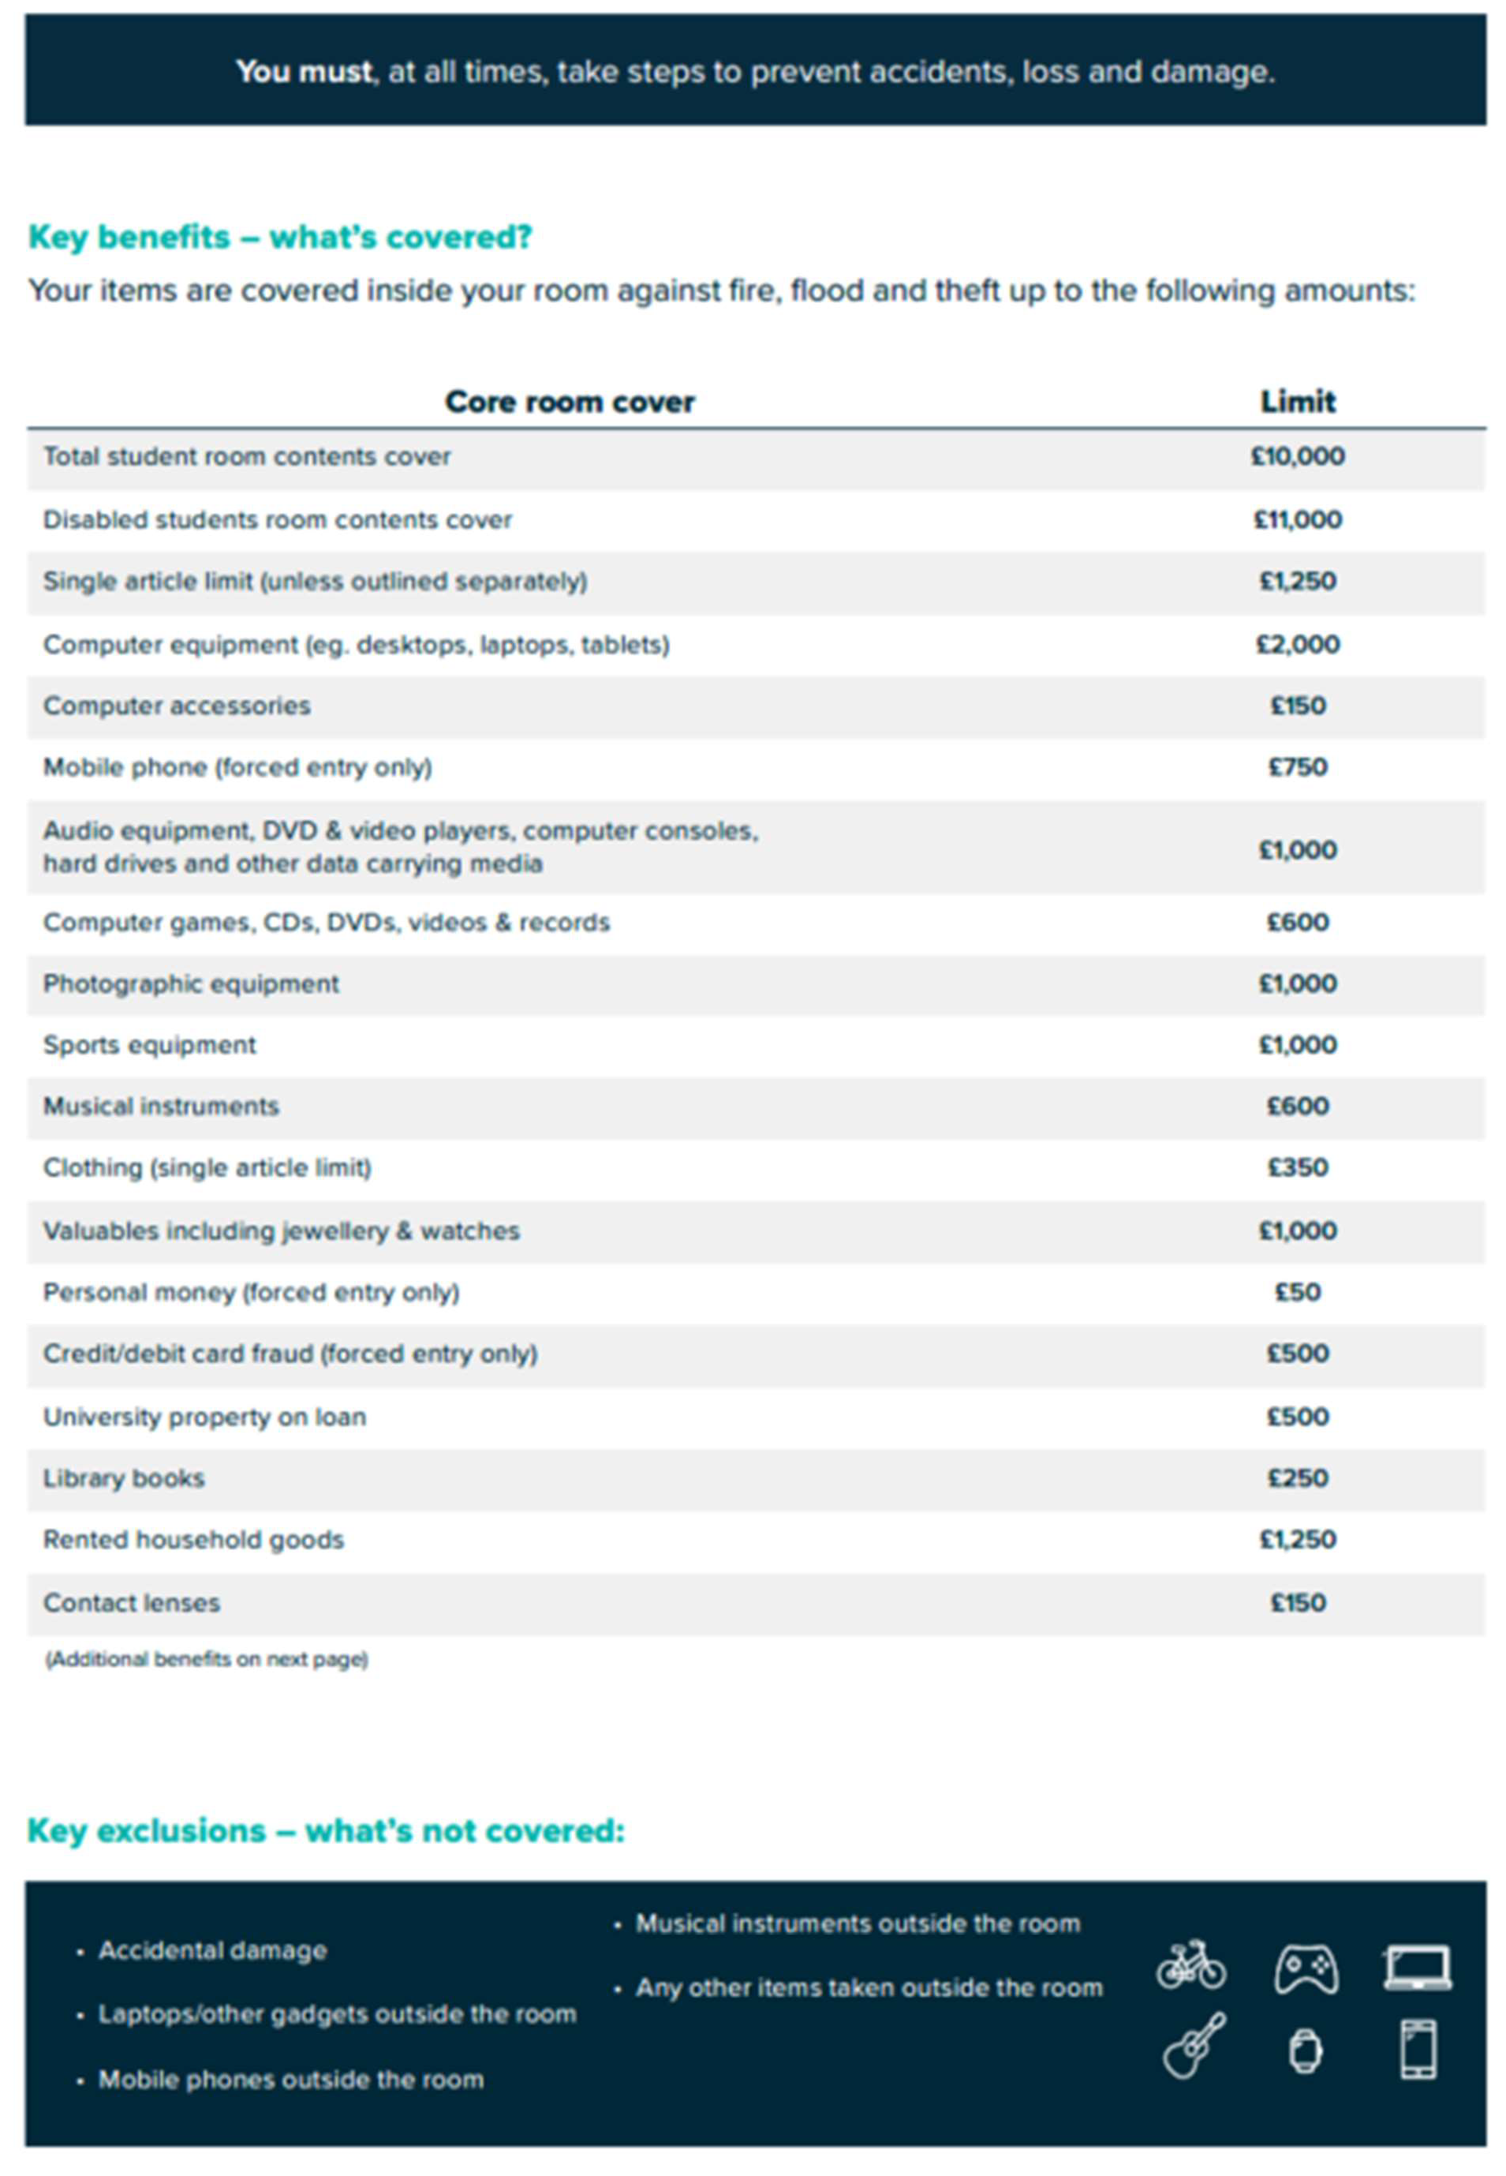

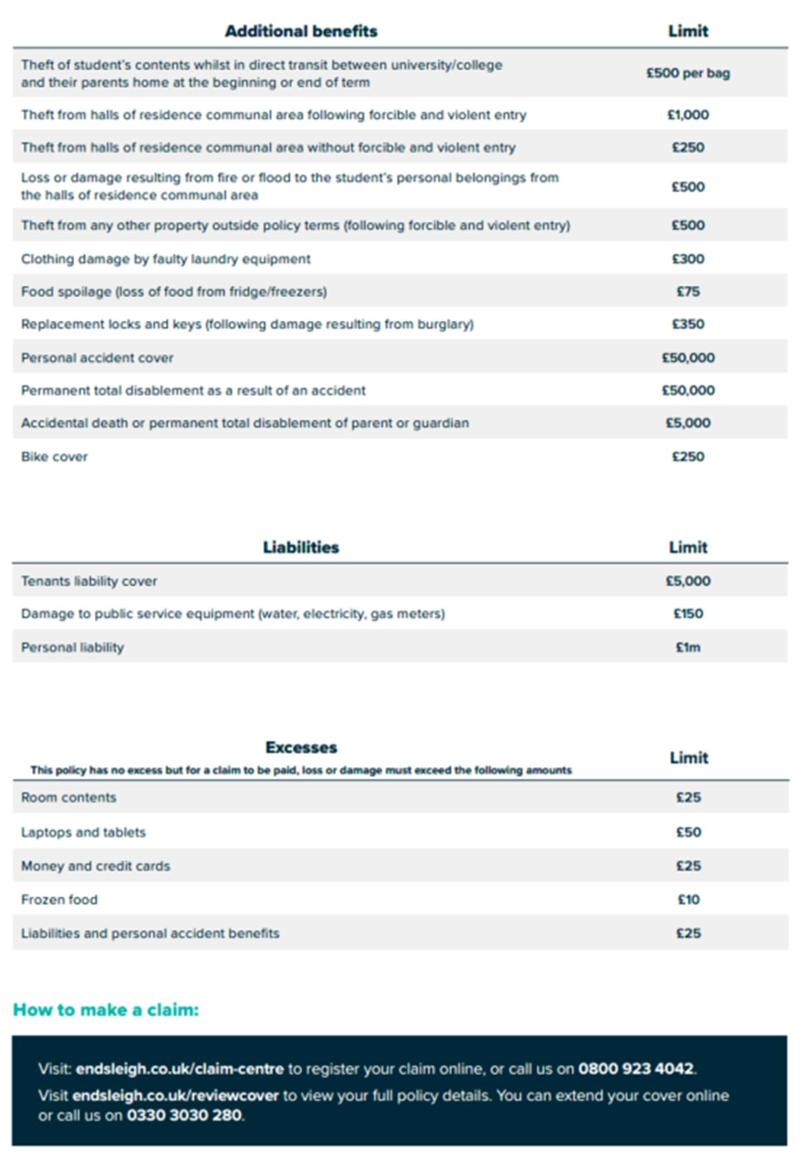

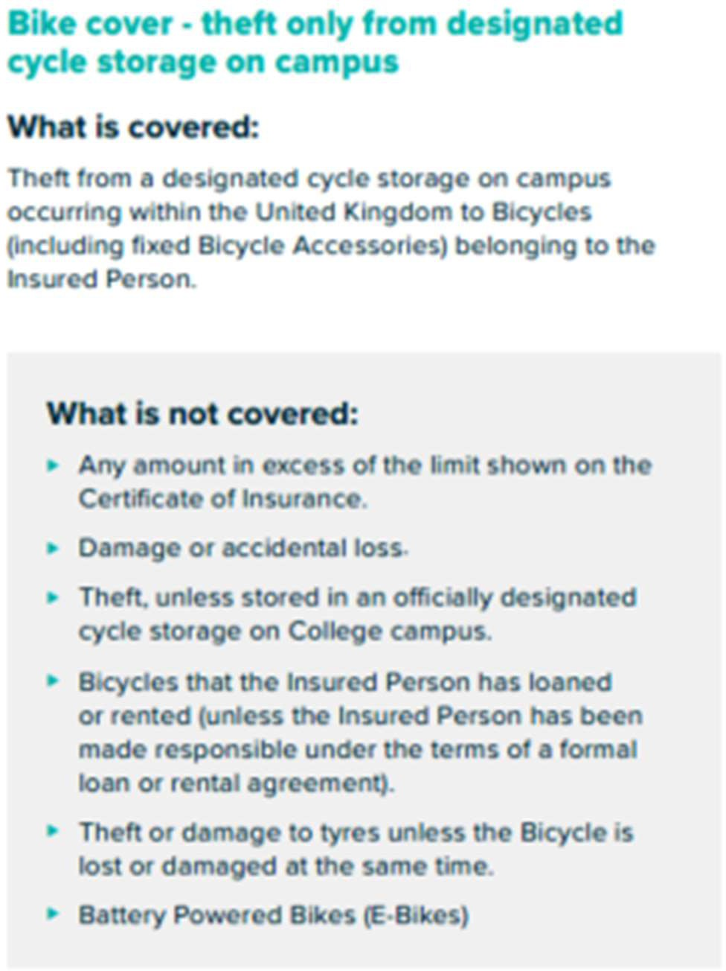

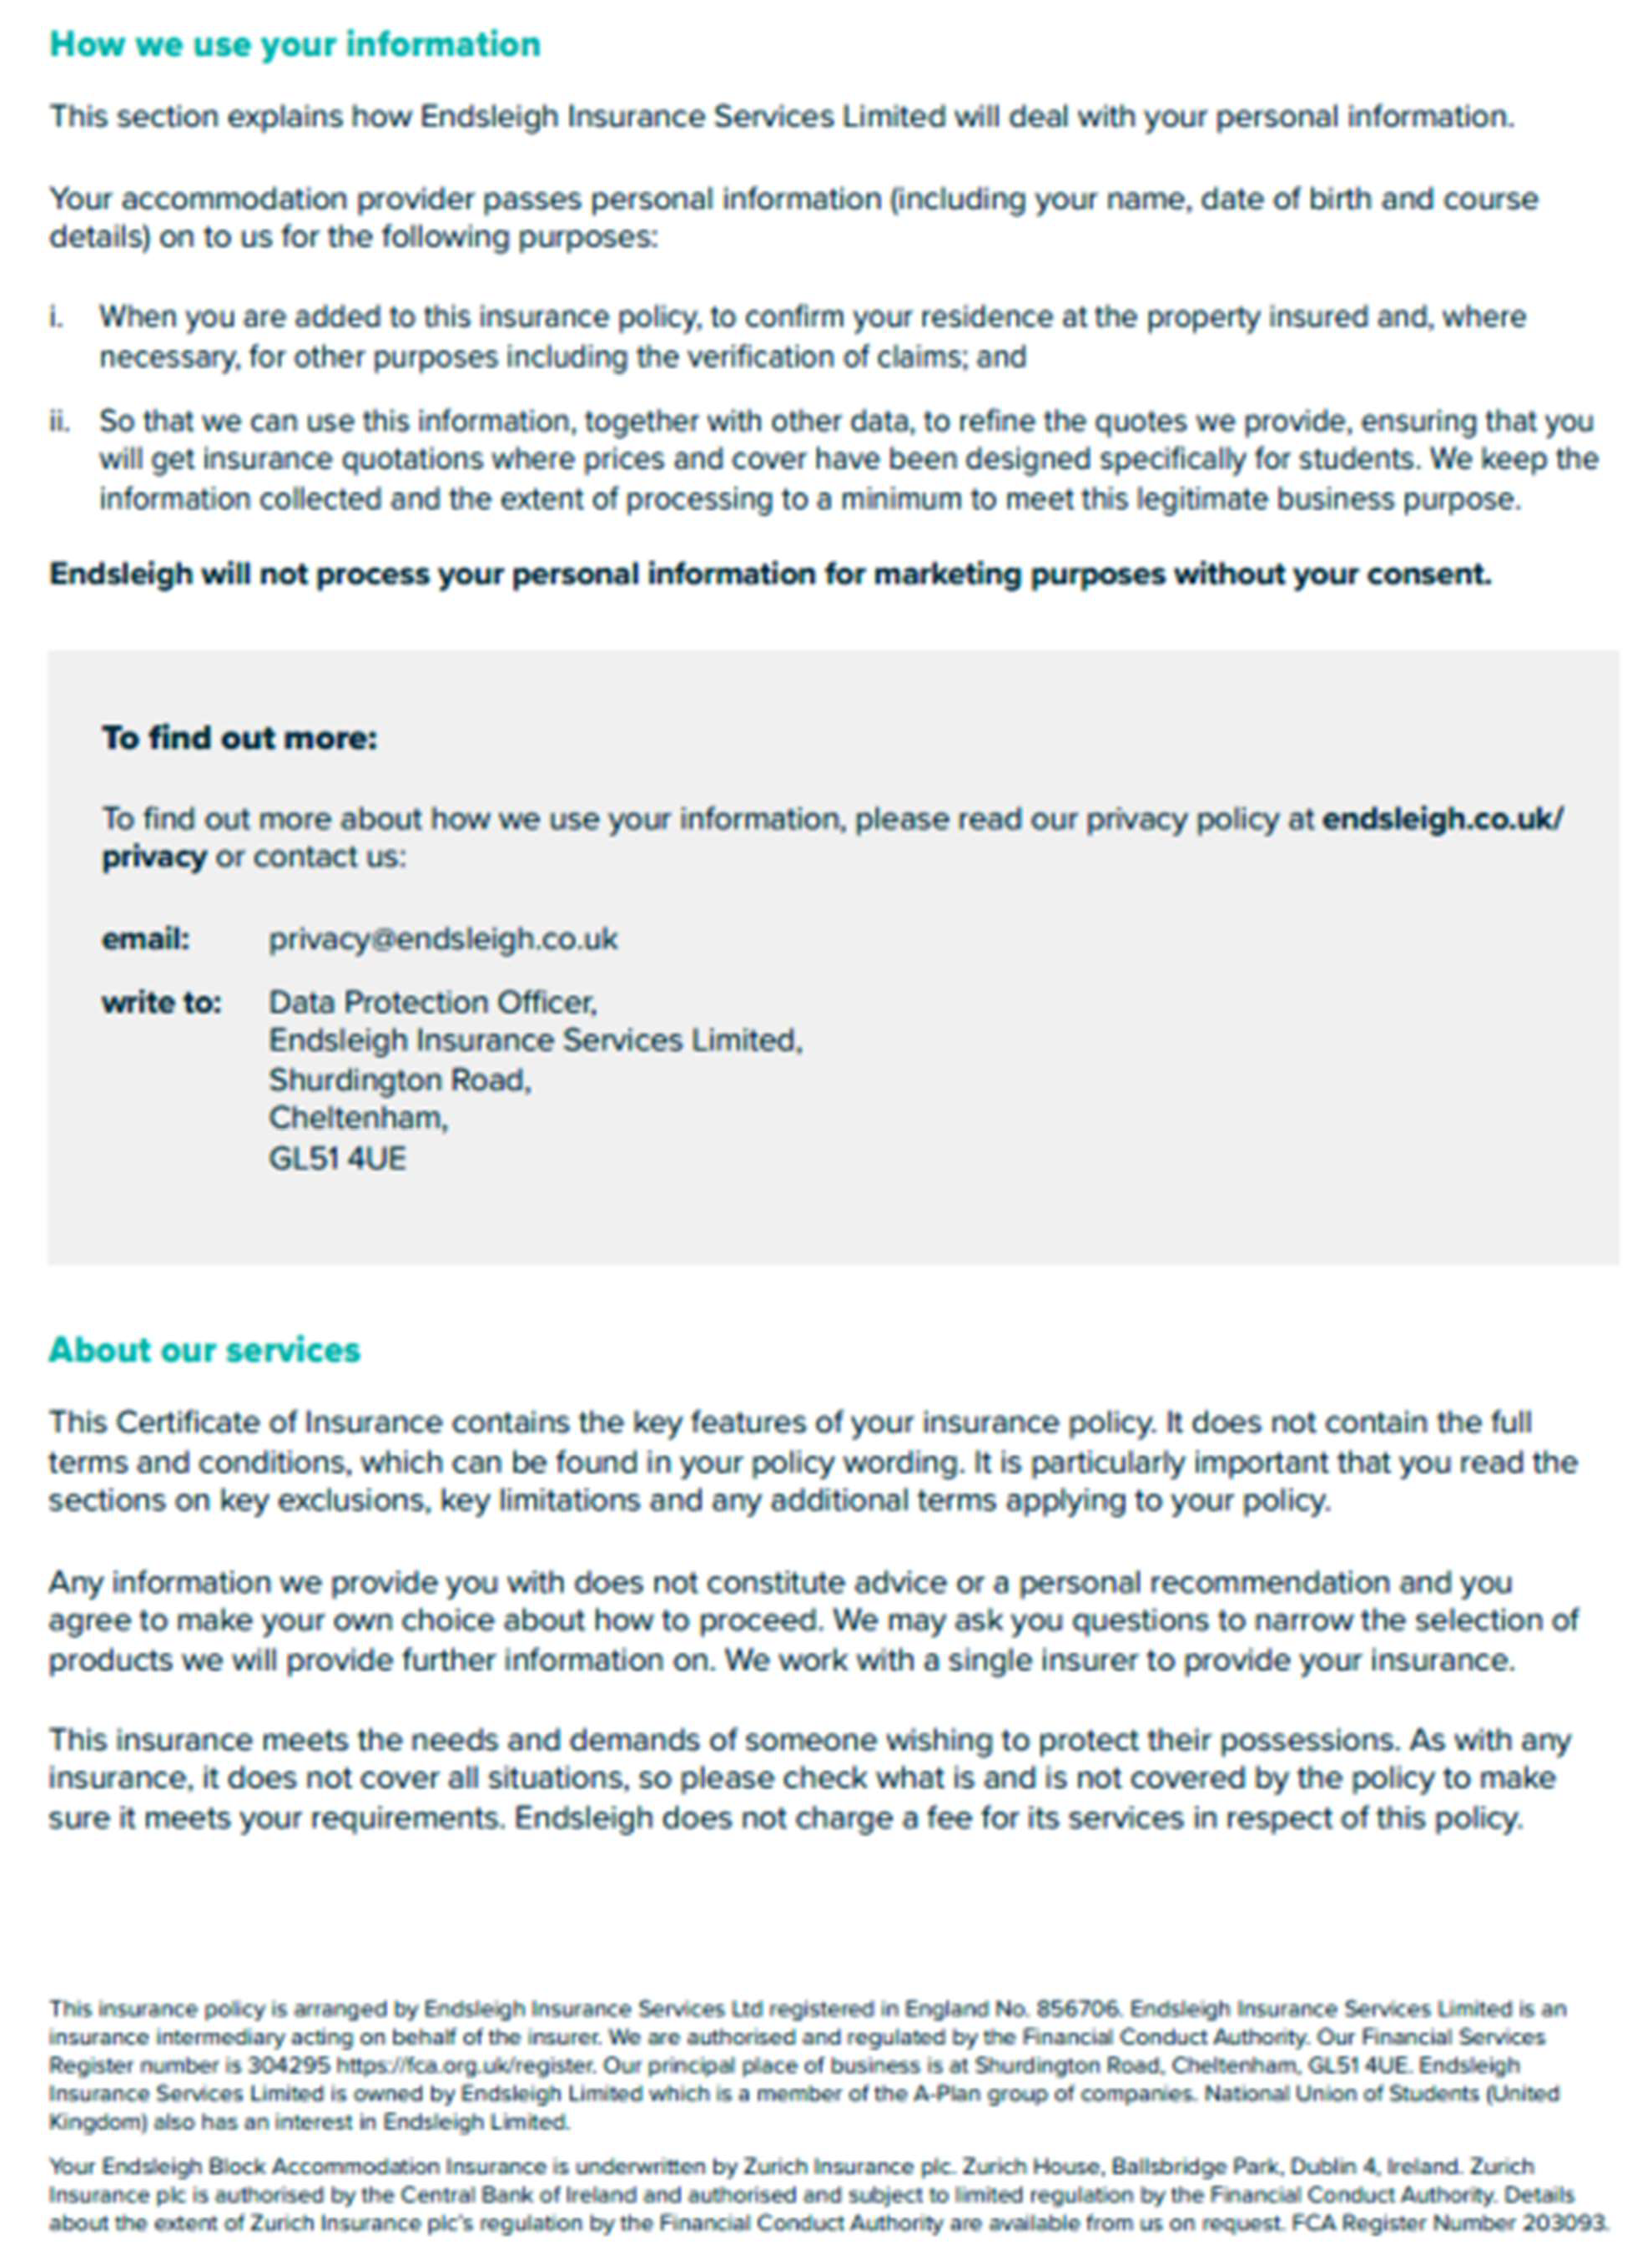

- USEFUL CONTACT DETAILS

There are many people throughout the University who are available to provide financial advice and guidance to students. Do not wait until you find yourself in difficulty. Resources are available to help you budget effectively and help you find ways to manage your money.

COLLEGE RESOURCES:
Domestic Bursar: Frances Lloyd domestic.bursar@wadham.ox.ac.uk
Finance Bursar: Peter Alsop finance.bursar@wadham.ox.ac.uk
Accountant: Vince Skeffington vince.skeffington@wadham.ox.ac.uk Welfare Dean: Olivia Vázquez-Medina olivia.vazquez-medina@wadham.ox.ac.uk Chaplain: Jane Baun jane.baun@wadham.ox.ac.uk
Senior Tutor: Michael Froggatt senior.tutor@wadham.ox.ac.uk Tutor for Equality & Diversity: Emily McLaughlin emily.mclaughlin@wadham.ox.ac.uk

UNIVERSITY RESOURCES
Student Fees and Funding Funding enquiries: Bursary enquiries:
Fee enquiries:
US loan enquiries:

www.ox.ac.uk/students/fees-funding student.funding@admin.ox.ac.uk bursaries@admin.ox.ac.uk student.fees@admin.ox.ac.uk us.loans@admin.ox.ac.uk

Oxford MCR RESOURCES
MCR President mcr.president@wadham.ox.ac.uk

Wadham MCR Welfare Officer Women’s Officer
mcr.welfare@wadham.ox.ac.uk mcr.women@wadham.ox.ac.uk

LGBTQ+ Officer huiru.wang@wadham.ox.ac.uk
POC/BME Officer mcr.poc@wadham.ox.ac.uk

USEFUL WEBSITES
www.gov.uk/student-finance www.studentfinanceni+.co.uk www.saas.gov.uk www.studentfinancewales.co.uk www.hmrc.gov.uk/students www.moneysavingexpert.com/students/

www.studentcalculator.org.uk www.money4medstudents.org www.thebrightsidetrust.org https://www.totum.com/ www.ucas.com

The information in this guide is intended for students commencing their studies in 2022/23 and is correct as of July 2022. For the latest information, for both new and returning students, please visit www.ox.ac.uk/students/fees-funding

