An Introductory Masterclass: Law
Miss Hart (mhart@queensbury.anthemtrust.uk)

An Introductory Problem

We all have a general understanding of what we feel the Law is, and should be. After all, we live according to its limits and guidance every day.

Task: Take a look at the problem below and decide what you think the outcome should be and why.
You are climbing a mountain with two friends. You are all tethered together.  Sophie, who is tethered below you, slips and falls off the edge. You can’t see her and have tried calling but can’t hear anything. There is no way to pull her back up. Her weight is pulling the other two of you down, and pulling your fixtures out.  You decide to cut the rope, knowing that she has a long way to fall and will die.  Should you be liable for the murder of Sophie or should you have a defence? | My Response:

Some Key Terms

At times learning the Law can feel like learning a new language. Here’s some of the ideas and terms that we will need today

Term | Means
Defence of excuse

Common law

Case Law

Civil Law

Criminal Law

Supreme Court

The Binding Law (we call this precedent):

R v Dudley & Stephens 1884
What happened?

The decision of the court (ratio):
Necessity cannot be a defence to murder, if it’s not to theft, as if we allowed it it would be : “be made the legal cloak for unbridled passion and atrocious crime”

What does this mean?

A Modern Dilemma

Re: A (Conjoined Twins)
What happened?

Note: This is not a criminal case, it is a civil case as it focused on the decision as to whether the doctors could perform the operation or not. However, in deciding this, the Court looked at what the decision might mean for the doctors’ liability for any actions they took, including murder.

The decision of the court (ratio):

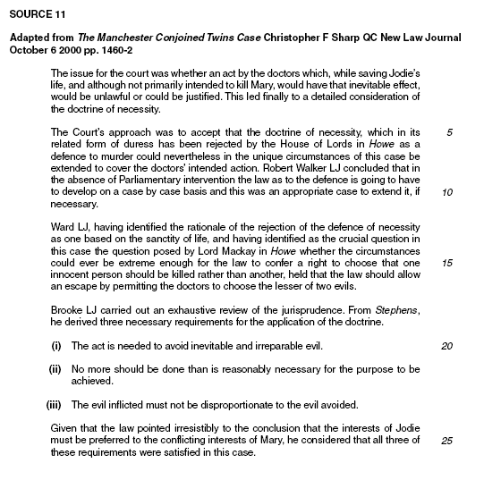

Thinking

What principle[s] underlie the use of necessity as a defence?

What offences is necessity a defence to?

What is the test to be applied by the courts in future cases?

Is the decision of the Court of Appeal a general one, applicable to all other cases?

So, what do you think? Do either of these cases fit the criteria?

R v Quayle | Nicklinson v Home Office
Brief Facts:  Does it fit the criteria? Why? Why not? | Brief Facts:  Does it fit the criteria? Why? Why not?

Homework Task

Using your understanding of the law, and referring to at least one case, explain whether you think the court would find that you did have a defence of necessity or not and why.

Impact of Necessity on Euthanasia | More detail on Dudley and Stephens: | A More recent attempt to plead it:
https://www.independent.co.uk/news/uk/home-news/jerome-taylor-why-the-necessity-defence-is-rarely-granted-7562837.html | https://www.irishtimes.com/news/crime-and-law/necessity-is-no-defence-for-murder-1.519637 | https://www.theguardian.com/uk-news/2018/dec/04/stansted-activists-cannot-use-defence-of-acting-for-human-rights-says-judge

