Topic: The Fibonacci Sequence

1. Fact sheet
The Fibonacci sequence
- The Fibonacci sequence is one of the most famous formulas in mathematics.
- In the 1202 AD, Leonardo Fibonacci wrote in his book “Liber Abaci” of a simple numerical sequence that is the foundation for an incredible mathematical relationship behind phi.
- This sequence was known as early as the 6th century AD by Indian mathematicians, but it was Fibonacci who introduced it to the west after his travels throughout the Mediterranean world and North Africa. He is also known as Leonardo Bonacci, as his name is derived in Italian from words meaning “son of (the) Bonacci”.
- Each number in the sequence is the sum of the two numbers before it.
- The sequence goes: 0, 1, 1, 2, 3, 5, 8, 13, 21, 34, and so on.
- The mathematical equation describing it is Xn+2= Xn+1 + Xn
- It's been called "nature's secret code" and "nature's universal rule."
Fibonacci numbers and the Golden Ratio
- The relationship of the Fibonacci sequence to the golden ratio is this: The ratio of each successive pair of numbers in the sequence approximates Phi (1.618. ….), as 5 divided by 3 is 1.666…, and 8 divided by 5 is 1.60.
- If we take the ratio of two successive numbers in Fibonacci's series, (1, 1, 2, 3, 5, 8, 13, ..) and we divide each by the number before it, we will find the following series of numbers:
1/1 = 1, 2/1 = 2, 3/2 = 1·5, 5/3 = 1·666..., 8/5 = 1·6, 13/8 = 1·625, 21/13 = 1·61538...

- It is easier to see what is happening if we plot the ratios on a graph:
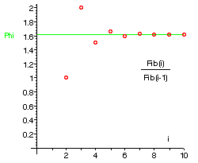
- The ratio seems to be settling down to a particular value, which we call the golden ratio or the golden number. It has a value of approximately 1·618034
- The golden ratio (first described by the Greek mathematician Euclid, in the 4th century BC) has been regarded by artists throughout history as the perfect, most beautiful proportion.
- The golden ratio 1·618034 is also called the golden section or the golden mean or just the golden number. It is often represented by a Greek letter Phi . The closely related value which we write as phi with a small "p" is just the decimal part of Phi, namely 0·618034.

2. What is the Fibonacci Sequence?

Leonardo Fibonacci discovered the sequence which converges on phi.
In the 1202 AD, Leonardo Fibonacci wrote in his book “Liber Abaci” of a simple numerical sequence that is the foundation for an incredible mathematical relationship behind phi. This sequence was known as early as the 6th century AD by Indian mathematicians, but it was Fibonacci who introduced it to the west after his travels throughout the Mediterranean world and North Africa. He is also known as Leonardo Bonacci, as his name is derived in Italian from words meaning “son of (the) Bonacci”.
Starting with 0 and 1, each new number in the sequence is simply the sum of the two before it.
0, 1, 1, 2, 3, 5, 8, 13, 21, 34, 55, 89, 144, 233, 377 . . .
This sequence is shown in the right margin of a page in Liber Abaci, where a copy of the book is held by the Biblioteca Nazionale di Firenze.
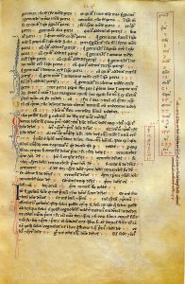
The relationship of the Fibonacci sequence to the golden ratio is this: The ratio of each successive pair of numbers in the sequence approximates Phi (1.618. . .), as 5 divided by 3 is 1.666…, and 8 divided by 5 is 1.60. (Source: https://www.goldennumber.net/fibonacci-series/)

3.What is the golden ration?
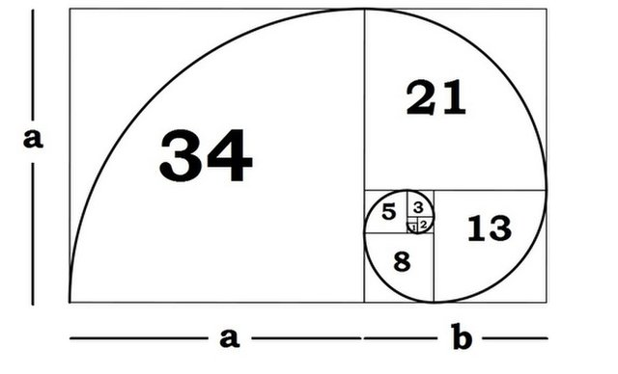
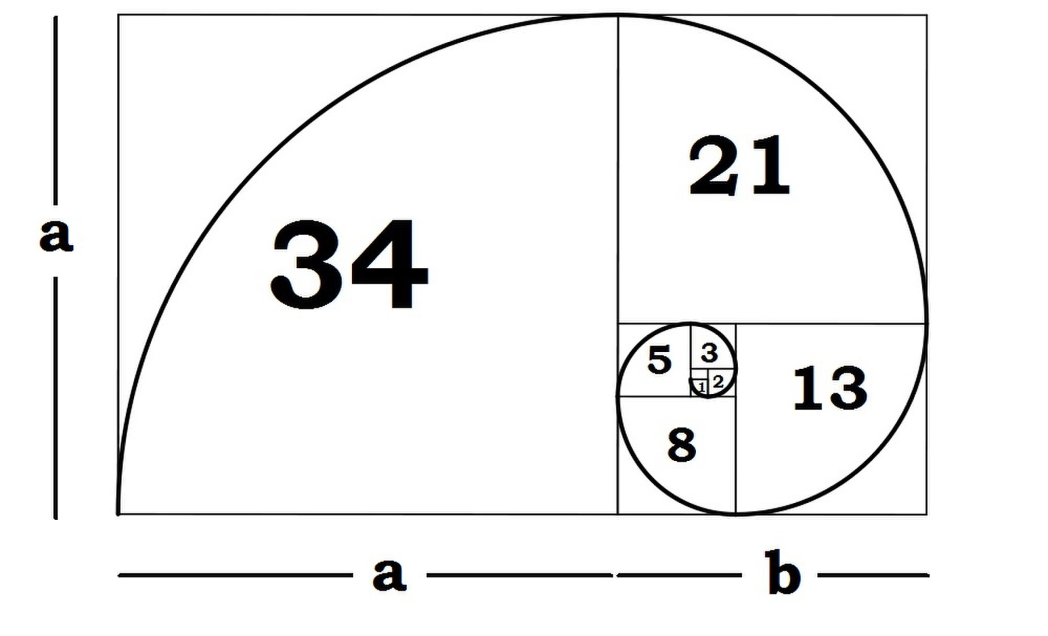
In the golden ratio, a + b is to a as a is to b.
The Golden ratio is a special number found by dividing a line into two parts so that the longer part divided by the smaller part is also equal to the whole length divided by the longer part. It is often symbolized using phi, after the 21st letter of the Greek alphabet. In an equation form, it looks like this:
a/b = (a+b)/a = 1.6180339887498948420 …
As with pi (the ratio of the circumference of a circle to its diameter), the digits go on and on, theoretically into infinity. Phi is usually rounded off to 1.618. This number has been discovered and rediscovered many times, which is why it has so many names — the Golden mean, the Golden section, divine proportion, etc. Historically, the number can be seen in the architecture of many ancient creations, like the Great Pyramids and the Parthenon. In the Great Pyramid of Giza, the length of each side of the base is 756 feet with a height of 481 feet. The ratio of the base to the height is roughly 1.5717, which is close to the Golden ratio.

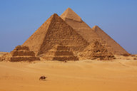
The Pyramids of Giza, built between 2589 and 2504 BC.
Credit: Dan BreckwoldtShutterstock
Phidias (500 B.C. - 432 B.C.) was a Greek sculptor and mathematician who is thought to have applied phi to the design of sculptures for the Parthenon. Plato (428 B.C. - 347 B.C.) considered the Golden ratio to be the most universally binding of mathematical relationships. Later, Euclid (365 B.C. - 300 B.C.) linked the Golden ratio to the construction of a pentagram.
Around 1200, mathematician Leonardo Fibonacci discovered the unique properties of the Fibonacci sequence. This sequence ties directly into the Golden ratio because if you take any two successive Fibonacci numbers, their ratio is very close to the Golden ratio. As the numbers get higher, the ratio becomes even closer to 1.618. For example, the ratio of 3 to 5 is 1.666. But the ratio of 13 to 21 is 1.625. Getting even higher, the ratio of 144 to 233 is 1.618. These numbers are all successive numbers in the Fibonacci sequence.
These numbers can be applied to the proportions of a rectangle, called the Golden rectangle. This is known as one of the most visually satisfying of all geometric forms – hence, the appearance of the Golden ratio in art. The Golden rectangle is also related to the Golden spiral, which is created by making adjacent squares of Fibonacci dimensions.
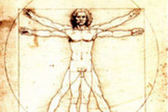
Leonardo da Vinci's 'Vitruvian Man' is said to illustrate the golden ratio.
In 1509, Luca Pacioli wrote a book that refers to the number as the "Divine Proportion," which was illustrated by Leonardo da Vinci. Da Vinci later called this sectio aurea or the Golden section. The Golden ratio was used to achieve balance and beauty in many Renaissance paintings and sculptures. Da Vinci himself used the Golden ratio to define all of the proportions in his Last Supper, including the dimensions of the table and the proportions of the walls and backgrounds. The Golden ratio also appears in da Vinci's Vitruvian Man and the Mona Lisa. Other artists who employed the Golden ratio include Michelangelo, Raphael, Rembrandt, Seurat, and Salvador Dali.
The term "phi" was coined by American mathematician Mark Barr in the 1900s. Phi has continued to appear in mathematics and physics, including the 1970s Penrose Tiles, which allowed surfaces to be tiled in five-fold symmetry. In the 1980s, phi appeared in quasi crystals, a then-newly discovered form of matter.
Phi is more than an obscure term found in mathematics and physics. It appears around us in our daily lives, even in our aesthetic views. Studies have shown that when test subjects view random faces, the ones they deem most attractive are those with solid parallels to the Golden ratio. Faces judged as the most attractive show Golden ratio proportions between the width of the face and the width of the eyes, nose, and eyebrows. The test subjects weren't mathematicians or physicists familiar with phi — they were just average people, and the Golden ratio elicited an instinctual reaction.
The Golden ratio also appears in all forms of nature and science. Some unexpected places include:
Flower petals: The number of petals on some flowers follows the Fibonacci sequence. It is believed that in the Darwinian processes, each petal is placed to allow for the best possible exposure to sunlight and other factors.
Seed heads: The seeds of a flower are often produced at the center and migrate outward to fill the space. For example, sunflowers follow this pattern.
Pinecones: The spiral pattern of the seed pods spiral upward in opposite directions. The number of steps the spirals take tend to match Fibonacci numbers.
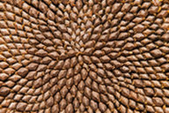
Sunflower seeds grow in Fibonacci spirals.
Credit: Sarah2 / Shutterstock
Tree branches: The way tree branches form or split is an example of the Fibonacci sequence. Root systems and algae exhibit this formation pattern.
Shells: Many shells, including snail shells and nautilus shells, are perfect examples of the Golden spiral.
Spiral galaxies: The Milky Way has a number of spiral arms, each of which has a logarithmic spiral of roughly 12 degrees. The shape of the spiral is identical to the Golden spiral, and the Golden rectangle can be drawn over any spiral galaxy.
Hurricanes: Much like shells, hurricanes often display the Golden spiral.
Fingers: The length of our fingers, each section from the tip of the base to the wrist is larger than the preceding one by roughly the ratio of phi.
Animal bodies: The measurement of the human navel to the floor and the top of the head to the navel is the Golden ratio. But we are not the only examples of the Golden ratio in the animal kingdom; dolphins, starfish, sand dollars, sea urchins, ants and honeybees also exhibit the proportion.
DNA molecules: A DNA molecule measures 34 angstroms by 21 angstroms at each full cycle of the double helix spiral. In the Fibonacci series, 34 and 21 are successive numbers

(Source: https://www.mathsisfun.com/numbers/golden-ratio.html)

4. Google Logo and the Golden Ratio in Design

New Google logo design finds visual harmony using the Golden Ratio.

Google’s design follows in the footsteps of Leonardo da Vinci and other masters
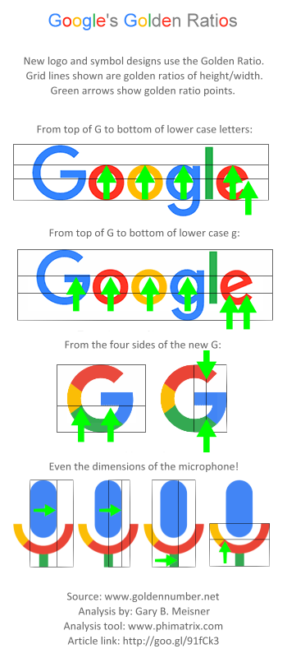
When Luca Pacioli published “The Divine Proportion” in 1509 (with illustrations by Leonardo da Vinci), he described his work on this “golden ratio” of 1.618 as a “very delicate, subtle and admirable teaching” that would “delight in diverse questions touching on a very secret science.” Johannes Kepler later called it “a precious jewel” of geometry. The designers at Google have apparently found its value too, as we see when we study and appreciate the underlying design of Google’s new logo, iconic G, the microphone icon and even the layout of the Google search page.

This is the kind of thoughtful design work that follows in the footsteps of Leonardo, Michelangelo, Raphael, Botticelli, Seurat, Le Corbusier and other masters of design, and that would make Pacioli proud.

Here’s a version without the arrows for a clearer view:
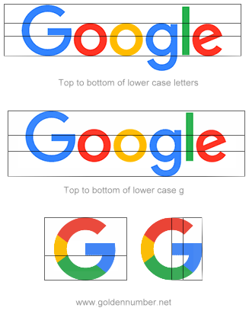
There’s a good chance you’ve used Google to search the Internet lately, maybe even in getting to this site. With over a billion people visiting per month, Google obviously puts in a lot of thought to create the best possible experience in using their search page. As simple as it is, the design of the logo and its search page has evolved considerably over the years. Consider how Google looked in 1998:
Logos and trademarks are critically important to a company’s image and brand recognition. On September 1, 2015, Google announced the new design for its logo and other trademarks. Their ongoing refinements of the logo and related design elements have led to the use the Golden Ratio (GR) in its design.

Golden ratios in the new logo and symbol are revealed by graphic analysis
For those not familiar with the golden ratio, it’s a simple as this:
- Divide a line into two segments, a and b.
- The ratio of the longer segment a to the shorter segment b must be the same as the ratio of the original line (a+b) to the longer segment a.
- That unique dividing point is the “Golden Ratio.”

The grid lines shown on logos in this article represent the golden ratio(s) of the height or width shown by the grid:
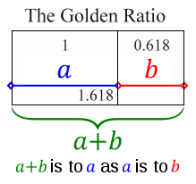
Let’s now see how the Golden Ratio appears in this new design, aided by the pixel-level accuracy of PhiMatrix design and analysis software:
- The height of the lower case letters is a GR of the height of the capital “G.”
- The upper point on the right side of the “e” is a GR of the height of the lower case letters.

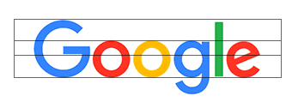
Next, take the height of the letters from the top of the upper case “G” to the bottom loop of the lower case “g”. Note alignment with the golden ratio lines at:
- The upper line of the crossbar on the upper case “G.”
- The inside edge of the lower case “o”, “g” and “e”.
- The pointed tip on the bottom curve of the lower case “e”.
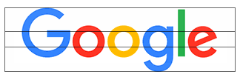
The new Google G symbol
The new Google “G” symbol also closely aligns with the Golden Ratio in it’s design:
- Horizontally – The bottom of the crossbar of the “G” and the inside point of the green arc align with the GR lines horizontally.
- Vertically – The inside points of the red and green circles fall at vertical GR lines of from the center of the “G” to the right edge of the “G”.
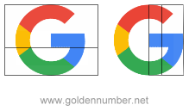

The new Google microphone symbol
My analysis reveals that new Google microphone symbol has a surprising number of golden ratios that were taken into account in its simple but very elegant design:
- The blue microphone is a GR of the inside and outside diameters of the circular arc the surrounds it.
- The width of the microphone stand is a GR of the width of the inner diameter of the circular arc.
- The point at which the color changes from gold to red appears at a GR of the height of the circular arc from the base of the stand.
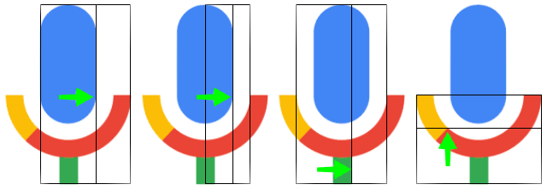
These are quite intricate design decisions for such a small icon. Think though how it ever so subtly relates it to the logo above it. It creates visual harmony by using same proportions for the design of all the elements of the composition. These same techniques appear in the composition of paintings and buildings by recognized masters of design, back to the Renaissance and before.

Golden Ratios throughout the new font created for letters in the logo
We also find the golden ratio in use in the width of the letters and other fine detail of the new font that Google calls Product Sans. Look at the width of the letters in relationship to each other.
- The width of the lower case “g” is a GR of the upper case “G”.
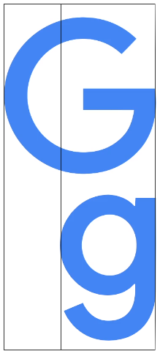
- The width of the lower case “l” is in GR proportion to the lower case “g”:
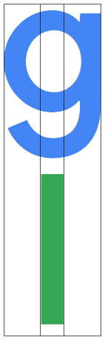
- The points on the lower arc of the lower case “g” are also based on Golden Ratios:
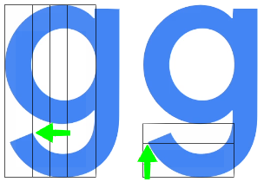
- The diameter of the hole inside the “o” is a GR of the height of the “o”. That in turn makes the line thickness of the “o” a GR of the radius of the hole.
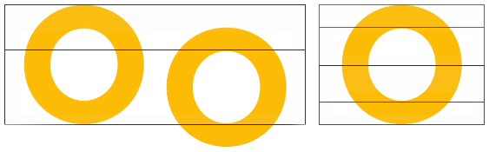
- The capital G for the Google icon was designed with exactly the same approach:
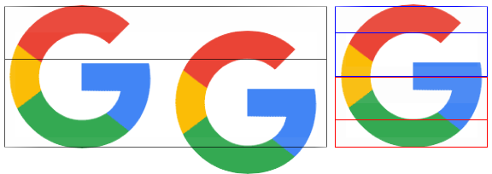
The PhiMatrix grids used above make this kind of design easy to do. For those just itching for a little math at this point, here’s how this works:
- When the diameter/height of the outer circle for the “G” and “o” is the Golden Ratio of 1.618, the diameter/height of the hole inside the circle is 1.
- This leaves 0.618 remaining for the line thickness of the font above and below the hole.
- The line thickness of the font is thus half of that at 0.309.
- The radius of the hole is 0.5.
- The ratio of 0.5/0.309 is … 1.618 again!
It’s the unique mathematical properties of the Golden Ratio that makes this relationship happen … again and again and again …, and why it is so useful in achieving visual harmonies in design.
(https://www.goldennumber.net/google-logo-design-golden-ratio/)

5. Questions
- What is the Fibonacci sequence? When was it first used and who by?

- What is the Golden Ratio?

- How is the Golden Ratio related to the Fibonacci sequence?

- Where has the Golden Ratio been used in art and construction?

- Describe where the Golden Ratio can be found in science and nature

- How has Google used the Golden Ratio?

- Why do you think Google has used the Golden Ratio?

