Topic: Music

Fact Sheet
- Blues is a unique genre. It was created by the combination of African and western culture in Southern United States.

- Some notable blue musicians in the early time include Robert Johnson, Bessie Smith and Bukka White.

- In the early development of blues music, there were some musical elements used by the musicians. Some of them include banjo and piano.

- Many blues musicians use the harmony combination of the first, fourth and fifth chords when they like to create fantastic blues songs. To produce the wonderful melody, the blue musicians often use the seventh, fifth and flattened third notes. This style can be seen in various types of traditional blues songs.

- Banjo is one of the main musical instruments that the blues musician used in the early days. In 1900s, other musical elements such as guitar and piano were added to make the blues rich and fun.

- Improvisations have been made in this modern day. Blues are not traditional any more. People will use the modern musical instruments such as drums, bass, and harmony to make the blues music unique. Therefore, you can find that many sub genres were generated from blues.

- One of the fascinating blue genres that you can learn is blues-rock. This music is the combination of blues and rock. This type of music is used to entertain the young teenagers who love rock.

- There are many other sub genres that people can enjoy from blues. You can see that the blues is combined with R&B, hip hop, pop, and rock and roll. If you like to carry a new look on the music, combine blues with heavy metal or alternative genres.

- It is usually created from the 48 beat and 12-bar repetitive patterns.

- Some blues songs usually are created based on the stories about poverty, lost relationship, violence, racism, death, love and many more.

(Source: https://www.myinterestingfacts.com/blues-music-facts/)

A Brief History of The Blues
When you think of the blues, you think about misfortune, betrayal and regret. You lose your job, you get the blues. Your mate falls out of love with you, you get the blues. Your dog dies, you get the blues.
While blues lyrics often deal with personal adversity, the music itself goes far beyond self-pity. The blues is also about overcoming hard luck, saying what you feel, ridding yourself of frustration, letting your hair down, and simply having fun. The best blues is visceral, cathartic, and starkly emotional. From unbridled joy to deep sadness, no form of music communicates more genuine emotion.
The blues has deep roots in American history, particularly African-American history. The blues originated on Southern plantations in the 19th Century. Its inventors were slaves, ex-slaves and the descendants of slaves—African-American sharecroppers who sang as they toiled in the cotton and vegetable fields. It's generally accepted that the music evolved from African spirituals, African chants, work songs, field hollers, rural fife and drum music, revivalist hymns, and country dance music.
The blues grew up in the Mississippi Delta just upriver from New Orleans, the birthplace of jazz. Blues and jazz have always influenced each other, and they still interact in countless ways today.
Unlike jazz, the blues didn't spread out significantly from the South to the Midwest until the 1930s and '40s. Once the Delta blues made their way up the Mississippi to urban areas, the music evolved into electrified Chicago blues, other regional blues styles, and various jazz-blues hybrids. A decade or so later the blues gave birth to rhythm 'n blues and rock 'n roll.
No single person invented the blues, but many people claimed to have discovered the genre. For instance, minstrel show bandleader W.C. Handy insisted that the blues were revealed to him in 1903 by an itinerant street guitarist at a train station in Tutwiler, Mississippi.
During the middle to late 1800s, the Deep South was home to hundreds of seminal bluesmen who helped to shape the music. Unfortunately, much of this original music followed these sharecroppers to their graves. But the legacy of these earliest blues pioneers can still be heard in 1920s and '30s recordings from Mississippi, Louisiana, Texas, Georgia and other Southern states. This music is not very far removed from the field hollers and work songs of the slaves and sharecroppers. Many of the earliest blues musicians incorporated the blues into a wider repertoire that included traditional folk songs, vaudeville music, and minstrel tunes.
Without getting too technical, most blues music is comprised of 12 bars (or measures). A specific series of notes is also utilized in the blues. The individual parts of this scale are known as the blue notes.
Well-known blues pioneers from the 1920s such as Son House, Blind Lemon Jefferson, Leadbelly, Charlie Patton and Robert Johnson usually performed solo with just a guitar. Occasionally they teamed up with one or more fellow bluesmen to perform in the plantation camps, rural juke joints, and rambling shacks of the Deep South. Blues bands may have evolved from early jazz bands, gospel choirs and jug bands. Jug band music was popular in the South until the 1930s. Early jug bands variously featured jugs, guitars, mandolins, banjos, kazoos, stringed basses, harmonicas, fiddles, washboards and other everyday appliances converted into crude instruments.
When the country blues moved to the cities and other locales, it took on various regional characteristics. Hence the St. Louis blues, the Memphis blues, the Louisiana blues, etc. Chicago bluesmen such as John Lee Hooker and Muddy Waters were the first to electrify the blues and add drums and piano in the late 1940s.
Today there are many different shades of the blues. Forms include:
Traditional county blues: A general term that describes the rural blues of the Mississippi Delta, the Piedmont and other rural locales;
Jump blues: A danceable amalgam of swing and blues and a precursor to R&B. Jump blues was pioneered by Louis Jordan;
Boogie-woogie: A piano-based blues popularized by Meade Lux Lewis, Albert Ammons and Pete Johnson, and derived from barrelhouse and ragtime;
Chicago blues: Delta blues electrified;
Cool blues: A sophisticated piano-based form that owes much to jazz;
West Coast blues: Popularized mainly by Texas musicians who moved to California. West Coast blues is heavily influenced by the swing beat.
The Texas blues, Memphis blues, and St. Louis blues consist of a wide variety of subgenres. Louisiana blues is characterized by a swampy guitar or harmonica sound with lots of echo, while Kansas City blues is jazz oriented—think Count Basie. There is also the British blues, a rock-blues hybrid pioneered by John Mayall, Peter Green and Eric Clapton.

(Source: https://www.allaboutjazz.com/a-brief-history-of-the-blues-by-ed-kopp.php)

Image
The originators of blues music? The Spirituals were sung by 19th century African slaves
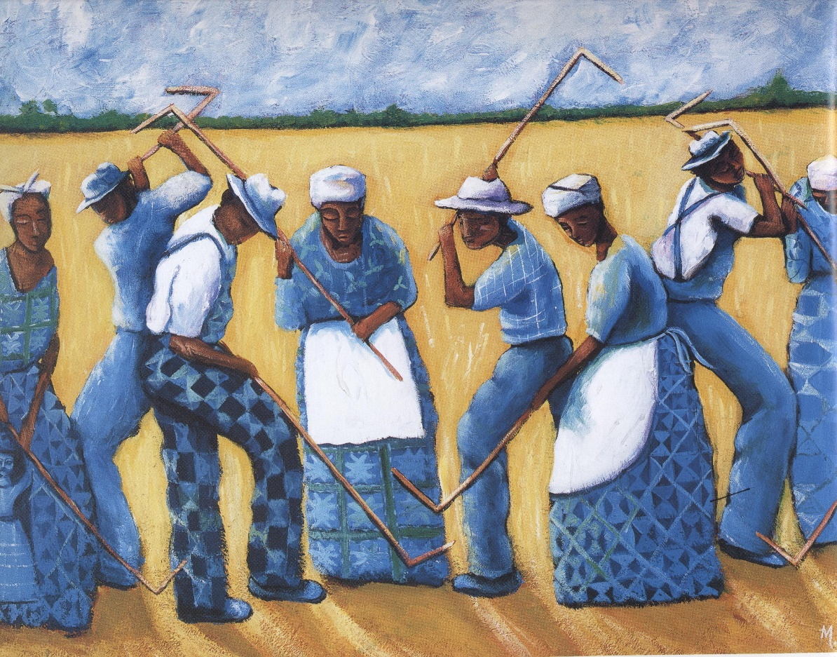

4. How Did Blues Influence Rock and Roll?
When we think of rock and roll, we think electric guitars, amplified sounds, and intricate styles of play, but what if I were to tell you rock and roll would not have existed without simple 12-bar forms, antiphonic textures, or walking bass lines used in blues music? Well I am here to tell you it is true. Blues music is one of the most influential characteristics that gave birth to rock and roll. Beginning in the Mississippi Delta region with African slave work songs and expanding to areas of Chicago and Dallas, blues went on to inspire rock legends such as: the Beatles, the Rolling Stones, and Jimi Hendrix.
Multiple elements in rock and roll provide evidence of common blues qualities. Rock and roll was influenced by elements of blues instrumentation, rhythm, and purpose. Both rock and blues are composed of drums, guitars, and vocals. As blues was becoming increasingly popular throughout the 1950s, manipulation of notes and amplifying instruments occurred. Muddy Waters, for example, began experimenting with increasing the dynamics of guitars and bending the notes of the guitars to give it a “cry” sound. Does this sound familiar? As blues music developed, it pushed the emergence of rock and roll more and more. Early rock and roll followed a similar rhythm to blues music as well. As it progressed, rock and roll would end up integrating more intense rhythmic elements with an accentuated backbeat, but the foundation was the same. The purpose behind the music, produced by blues and rock and roll, is designed from the same perspective. The goal of both these genres of music is to create music with raw emotion. The blues emotion-driven style of music inspired the same pattern to be followed by rock and roll.
Many famous rock and roll bands were influenced by similar popular blues artists such as: Chuck Berry, Muddy Waters, and Little Richard. Blues, along with the artists that produced it, was significant in the inspiration of the Beatles. The Beatles had a great deal of respect for Chuck Berry and what he did for music. Lennon once said, “If you tried to give rock and roll another name, you might call it ‘Chuck Berry’.” The Beatles credited Berry for being an important piece for creating rock and roll. Chuck Berry also influenced the Beatles with the lyrical content within his songs. The Beatles performed and recorded multiple covers of Berry’s songs like: “Sweet Little Sixteen,” “Carol,” “I Got to Find My Baby,” “Too Much Monkey Business,” “Johnny B Goode” etc. It is easy to see that blues had an impact on rock and roll because a rock and roll band considered one of the best that ever lived, integrated it into their music.
The Rolling Stones started out playing blues music in Britain and fused it with the rock and roll music they would be known for playing in the United States. The Rolling Stones were also a band influenced by the blues music of Chuck Berry. The Rolling Stones covered Berry’s songs like, “Come On”, and solidified the incorporation of blues roots into rock and roll. Muddy Waters was most likely the biggest influence on the Rolling Stones. They actually got the name for their band from the Muddy Waters song, “Rollin’ Stone”. The Rolling Stones often wrote blues songs with a heavier melody than improvisation. The Stones are one of the most obvious examples for showing the effect blues had on creating rock and roll.
Jimi Hendrix relied on a variety of blues artists for inspiration. Hendrix grew up listening to Little Richard, Muddy Waters, and Chuck Berry. Little Richard inspired Hendrix’s blues roots and the sound he wanted to create with his guitar. Jimi Hendrix stated, “I want to do with my guitar what Little Richard does with his voice.” Muddy Waters was the first guitarist Hendrix heard and he marvelled at the sounds Waters made with his guitar. Hendrix got his rock and roll attitude and over the top performance style from Chuck Berry. Berry was known for his famous duck walk and playing his guitar behind his head and in between his legs. Hendrix would follow by Berry’s example and put on charismatic performances.
Rock and roll borrowed so many different blues aspects and put them into its music and performances. Integrated blues aspects range from instrumentation to the story told behind the music. Whether influenced by blues music or blues musicians, the fact remains that blues had a monumental impact on the birth of rock and roll.
(Source: https://blogs.longwood.edu/reganwardensky/2012/12/03/how-did-blues-influence-rock-and-roll/)

5. Questions
1. Where is it generally accepted that Blues music originated?

2. How were instruments implemented to develop the style of blues music in the 1900’s?

3. What are said to be the key elements of the “best” blues music?

4. How are chords and notes combined to create traditional blues music?

5. How did the famous blues musician, Muddy Waters, contribute to popular Rock and Roll?

6. How does emotion play a part in Blues & Rock and Roll? Where do you think this stemmed from?

7. To what extent does Blues music continue to have an influence in the modern era?

