Topic: Fascism

Fact Sheet
Right wing
Although fascism contains some elements of left wing ideology, particularly in terms of its economic position, it is generally considered to be an extreme right-wing ideology.
Ultra Nationalist
Fascists are extremally nationalistic, viewing the nation as being of the highest importance. This can lead to them being intolerant of other cultures or practices that exist outside of their nation.
Rebirth of the nation
Fascists are convinced that their nation is in a dire state of moral and social decay, and that it needs to be returned to its state of former glory, rising like a phoenix from the ashes.
Authoritarian
Fascists are suspicious of liberal democracy and tend to prefer an authoritarian system where the state has ultimate control instead of the people. They often advocate a strong leader who can make their nation great again.

(Source: www.simplepolitics.co.uk/questions-and-answers/what-is-fascism)

German Fascism
Once in power Adolf Hitler turned Germany into a fascist state. Fascist was originally used to describe the government of Benito Mussolini in Italy. Mussolini's fascist one-party state emphasized patriotism, national unity, hatred of communism, admiration of military values and unquestioning obedience. Hitler was deeply influenced by Mussolini's Italy and his Germany shared many of the same characteristics.
The German economic system remained capitalistic, but the state played a more prominent role in managing the economy. Industrialists were sometimes told what to produce and what price they should charge for the goods that they made. The government also had the power to order workers to move to where they were required.
By taking these powers Hitler's government was able to control factors such as inflation and unemployment that had caused considerable distress in previous years. As the government generally allowed companies to maintain their profit margins, industrialists tended to accept the loss of some of their freedoms.
Under fascism, most potential sources of opposition were removed. This included political parties and the trade union movement. However, Adolf Hitler never felt strong enough to take complete control of the German Army, and before taking important decisions he always had to take into consideration how the armed forces would react.
By the time Hitler gained power he had ceased to be a practising Christian. He did not have the confidence to abolish Christianity in Germany. In 1934 Hitler signed an agreement with Pope Pius XI in which he promised not to interfere in religion if the Catholic Church agreed not to become involved in politics in Germany.
The individual had no freedom to protest in Hitler's Germany. All political organizations were either banned or under the control of the Nazis. Except for the occasional referendum, all elections, local and national, were abolished.
All information that people in Germany received was selected and organized to support fascist beliefs. As Minister of Propaganda, Joseph Goebbels kept a close check on the information provided by newspapers, magazines, books, radio broadcasts, plays and films.
Adolf Hitler, who had been deeply influenced by his own history teacher, was fully aware that schools posed a potential threat to the dominant fascist ideology. Teachers who were critical of Hitler's Germany were sacked and the rest were sent away to be trained to become good fascists. Members of the Nazi youth organizations such as the Hitler Youth, were also asked to report teachers who questioned fascism.
As a further precaution against young people coming into contact with information and the government disapproved of, textbooks were withdrawn and rewritten by Nazis.
(Source: http://spartacus-educational.com/GERfascist.htm)

Image
(Source: https://www.slideshare.net/christopherrice/fascism-146942)
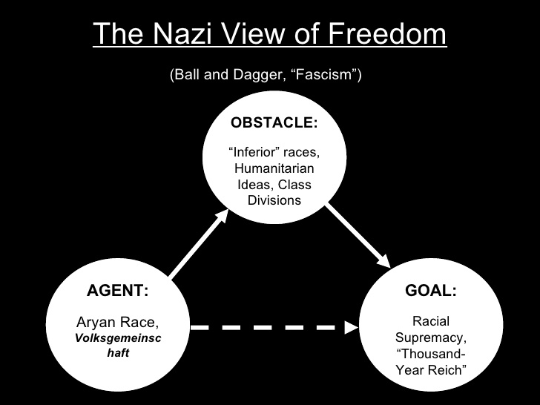

The Return of Fascism
(by Seyla Benhabib Espen Rasmussen - September 29, 2017)

On July 22, 2011, a Norwegian extremist named Anders Behring Breivik shot off an email to more than a thousand people. A self-identified fascist, Breivik attached a 1,500-page screed attacking Islam, cultural Marxism, feminism, and immigration. Titled “2083: A European Declaration of Independence,” the manifesto demanded the forced deportation of all Muslims from Europe. An hour and a half later, Breivik set off in a Volkswagen van to kill 77 people, first by detonating a fertilizer bomb in Oslo, then by gunning down teenagers at a summer camp on the island of Utoya. It was the bloodiest attack on Norwegian soil since World War II.

Breivik belonged to a group called the Norwegian Defense League, one of the many openly fascist movements that have cropped up all across Europe over the past decade, from Scandinavia to Germany, where, this past weekend, the far right won a stunning 13 percent of the vote in the German elections, enough to propel it into parliament for the first time in more than 60 years. In part, the rise of far-right nationalism is a reaction to the European Union, which sparked a backlash from an older generation of people who fear the loss of their identities as white Christians. As refugees streamed into Europe, those diffuse sentiments for a vanishing past have found easily identifiable targets. Pundits and politicians on the right have placed Islamophobia firmly at the centre of the new movements.

In Italy, the journalist Oriana Fallaci popularized the phrase “Eurabia” to demonize the continent’s growing population of Muslim immigrants. Even in Germany, which has engaged in an exemplary reckoning with its fascist past, the economist and politician Thilo Sarrazin wrote a runaway best-seller called Deutschland Schafft Sich Ab—Germany Is Destroying Itself—arguing that the upsurge in immigration has created a lower class that is dumber and more dependent on the state. That outlook laid the groundwork for the swift rise of Germany’s far-right populist party, the AfD: Four years ago, it earned less than five percent of the vote in the country’s elections. Last weekend, it won nearly three times that, an astonishing coup that throws the growing power of nationalism and Islamophobia in Europe into sharp relief.

Photographer Espen Rasmussen has spent almost two years documenting the rise of far-right extremists not just in Germany, but all over Europe, from the Golden Dawn in Greece to neo-Nazis in Ukraine. Some, like the National Front in France and Britain First in the United Kingdom, have entered the political mainstream. Many sit in the EU Parliament, using the funds of an organization whose destruction they seek. And all draw from the memories of Europe’s fascist past, in the period between the two World Wars, seeking answers to Europe’s contemporary problems. By putting the Nazi paraphernalia of these groups so vividly on display, Rasmussen’s photographs force us to confront the reality that there are forces that want Europe to fall apart rather than pull together. It is sobering to realize how far and fast such hatred can travel.

(Source: https://newrepublic.com/article/144954/return-fascism-germany-greece-far-right-nationalists-winning-elections)

Questions
1. What type of ideology is fascism generally seen to be?

2. Summarise the common traits of fascist ideology.

3. How does the Nazi view of freedom fit in with Fascist ideology?

4. What was significant about the German elections in September 2017?

5. How is Europe’s Fascist past seemingly contributing to the rise in Fascist movements. What are said to be the main concerns of these groups?

6. How was Hitler’s Germany influenced by Mussolini’s Italy?

7. What was Joseph Goebbels role during Hitler’s reign over Germany? How did he contribute to the widespread support of Fascist beliefs?

