Topic: Buddhism

Factsheet
Nirvana
- the endless cycle of life and death is a flux that can only be stopped by enlightenment, according to Buddhists
- enlightenment leads to Nirvana which means the end of all craving, the achievement of perfect non-attachment and of happiness
- Nirvana is not a place or a heaven; it is a state of mind that is available to all living beings in this life. It is a way of living and being in the world that is free of suffering and rich in wisdom, happiness and compassion.

Bodhisattva
- the term Bodhisattva refers to someone on the path to Awakening
- the Mahayana has conceived them as having renounced the ultimate state out of pure compassion towards all beings, and can therefore refer to anyone en route
- in Theravada Buddhism, it usually refers either to Maitreya, the Buddha of the Future, or to the historical Buddha Gautama prior to his enlightenment – either during the life in which he became enlightened or in one of the innumerable lives before that in which he was developing the requisite virtues for enlightenment, such as generosity.

Arhat
- when a Buddhist in the Theravada tradition realises that all worldly suffering is caused by craving and that it is possible to bring suffering to an end by following the Noble Eight Fold Path
- when that perfected state of insight is reached, i.e. Nibanna, that person is a ‘worthy person’, an Arhat
- the life of the Arhat is the ideal of the followers of this school, ‘a life where all (future) birth is at an end, where the holy life is fully achieved, where all that has to be done has been done, and there is no more returning to the worldly life’.

Anatta
- the Buddhist teaching of no-self or soul

The Five Skandhas
- the Buddhist analysis of personal experience or the Buddhist analysis of the personality. They are the impermanent, ever-changing elements of being that describe the impermanent entity that we label the ’self’.

Samsara
- the circle of suffering that, according to Buddhism is the destiny of all living beings until they achieve enlightenment and break the pattern of rebirth to experience the truth of existence.

The Buddhist Wheel of Life
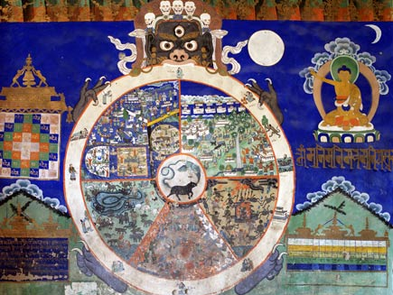

Photo © Falk Kienas/iStockphoto
Wheel of Life overview
The Bhavachakra, the Wheel of Life or Wheel of Becoming, is a mandala - a complex picture representing the Buddhist view of the universe. To Buddhists, existence is a cycle of life, death, rebirth and suffering that they seek to escape altogether.
The Wheel is divided into five or six realms, or states, into which a soul can be reborn. It is held by a demon. Around the rim are depicted the twelve stages of dependent origination. This gallery will explain the parts of the diagram.
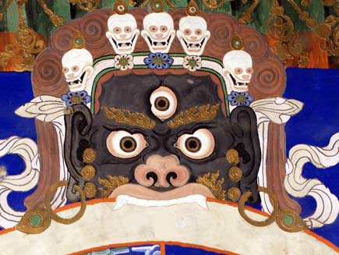
Yama
The frightening figure holding the wheel is Yama, the Lord of Death or Monster of Impermanence. He has three eyes and wears a crown of skulls.
Yama symbolises the impermanence of everything. The beings he holds are trapped in eternal suffering by their ignorance of the nature of the universe. Buddhism teaches that death is not the end and is not to be feared.

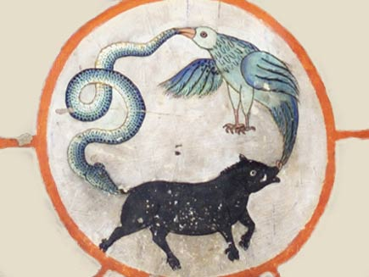
The Three Fires
In the middle of the Wheel are the three causes of all suffering. These are known as the Three Fires: they are greed, ignorance and hatred, represented by a rooster, a pig and a snake. They are shown linked together, biting each other's tails, reinforcing each other.
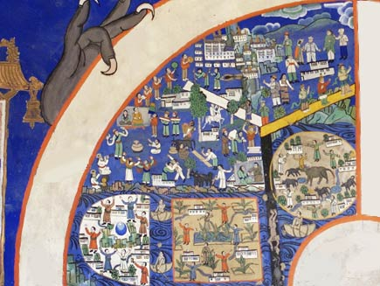
The realm of humans
Buddhists consider being born as a human to be the most fortunate state. Because they are not suffering as heavily as those in the other realms, yet are not in lengthy bliss like the gods, humans have the best chance of enlightenment.
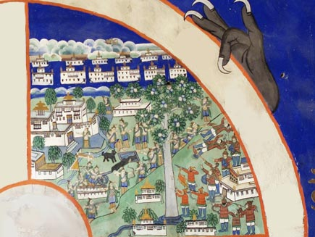
The realm of gods (and Titans)
The gods, or devas, live in a state of bliss in the realm of heaven. Later sources subdivide this into 26 levels of increasing happiness. The gods live for a long time, but they too will die. Only enlightenment is a complete release.
At the bottom are the angry gods, called Titans or asuras, who hate the devas. Later sources often show these in a realm of their own.

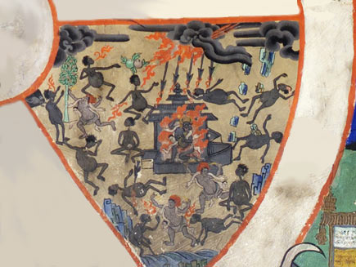
The realm of hungry ghosts
Lingering around the edges of the mortal realm, trapped by their overattachment to the world, the hungry ghosts, or pretas, are in the grip of their unfulfilled desires. This is symbolised by their huge bellies and tiny mouths that can never satisfy their appetites.

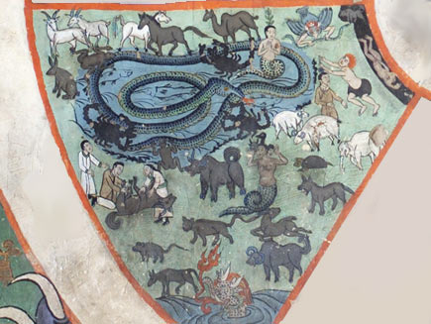
The realm of animals
Animals are used by humans and lack the necessary awareness to become enlightened. Buddhists do not believe it is a good thing to be reborn as an animal, although they believe in treating every living thing with loving kindness

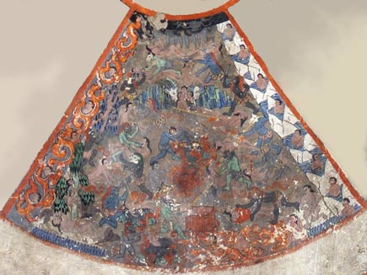
Hell
At the bottom is the hell realm. People here are horribly tortured in many creative ways, but not for ever - only until their bad karma is worked off.

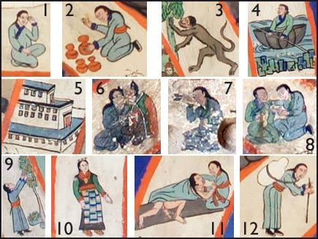
Dependent origination
The twelve stages of dependent origination are shown around the rim. They are: 1. Ignorance: a blind man; 2. Willed action: a potter; 3. Conditioned consciousness: a restless monkey; 4. Form and existence: a boat; 5. Senses: windows of a house; 6. Sense-impressions: two lovers; 7. Sensation: an arrow in the eye; 8. Craving: a man drinking; 9. Attachment: clinging to a fruit tree; 10. Becoming: a pregnant woman; 11. Birth; 12. Old age, death

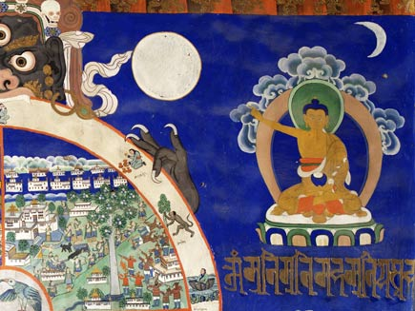

Buddha
In the top right corner, Buddha is showing the way. He is outside the wheel to show that he has escaped the cycle of life and death. Buddha is pointing to Yama and the wheel to teach his followers the true nature of existence.

Anatta and the Four Noble Truths
(adapted from a talk by Gil Fronsdal, October 1st, 2002)
People are often perplexed by the Buddha’s teaching of anatta, or not-self. One reason is because in different religions and schools of psychotherapy and philosophy, as well as in everyday language, the word “self” is used in many ways. When people talk about “the self” without defining their terms, they may be unknowingly talking about different things.
So, to understand the Buddha’s teaching of not-self, we must understand how the Buddha defined self, or, in his language, atta. First, we must distinguish between two uses of the word atta. In some religious circles at the time of the Buddha, atta referred to a form of metaphysical self. A metaphysical definition of self is any theory of the real nature of self; for example, a permanent abiding essence that survives death, or a true self that is larger or more essential than the personality or the individual. In this sense atta could be translated into English as “the Self” or “the Soul.” Quite distinct from the metaphysical use, atta was more commonly used as a reflective pronoun, like the English word “self” in such terms as “oneself” and “myself.” In this latter sense it was used as a simple convention of speech, rather than referring to any metaphysical or essential idea of “the self.”
We must keep both these uses of atta in mind in understanding the Buddha’s teachings. On the one hand, he clearly did not accept any metaphysical definitions of “Self.” On the other hand, he emphasized the suffering that can come with clinging to anything as belonging to or defining “myself.” The Buddha’s path of practice leads to the ending of this clinging.
The most common metaphysical “Self” against which the Buddha was arguing is implicitly defined in his Anatta Lakkhana Sutta, The Discourse on Anatta. For something to be atta, according to this view, it needed three components. It had to have complete control over the body, feelings, thoughts, impulses, intentions, consciousness, or perceptions. It had to be permanent. And it had to be blissful. In this discourse, the Buddha makes it clear that nothing in our psycho-physical experience has these three qualities and is therefore fit to be regarded as an atta or self.
Here in the modern West, this ancient Indian definition of the Self does not have much, if any, meaning. However, we have our own notions of what the self is or what it needs to be. In part these are the legacy of Western ideas of “soul,” and in part they derive from the strong human drive to identify with certain things as defining what this self is. We identify ourselves with our thoughts, feelings, consciousness, volition, personal characteristics, or with a sense of continuity. Held lightly and provisionally, such identifications may be useful. Held tightly, they are self-limiting. If we expend the energy to cling to anything as the definition of the self, we will sooner or later suffer. In order to find a deeply abiding peace, we need to learn to let go of any attachment to or habit of fixating on self-identity.
Contrary to popular conception, we have no record of the Buddha ever saying, “There is no self.” In the entire preserved volumes of the Buddha’s discourses, in only one place did someone actually ask the Buddha: “Is there no self?” The Buddha refused to answer the question. The same person then asked: “Is there a self?” This too the Buddha declined to answer. What the Buddha did say repeatedly is that no particular aspect of our psycho-physical being qualifies as atta or the Self. Not our body, not our feelings, not our thoughts, not our dispositions, and not our consciousness.
The Buddha’s teachings on self and not-self get even more subtle and fascinating. Aside from the specific definition of self he refuted in the Anatta Lakkhana Sutta, he argues that it is not useful to frame Buddhist practice through any conception of self. Views about the existence or non-existence of a self, or identifying the self with any characteristic or experience, even awareness itself, lead to a jumble of speculation. And more importantly, he claimed that they would not lead to liberation.
As an alternative to framing the spiritual life around the self, the Buddha suggests instead that we look at our experience through the framework of the Four Noble Truths, focusing honestly and directly on our suffering, the grasping that causes it, the peace or happiness that results from the release of grasping, and the way of living that supports a sense of well-being.
The Buddha’s teaching points us away from looking for the self, or trying to understand or improve the self. Instead it suggests that we pay attention to the fear, desire, ambition, and clinging that motivate the building of self-identity. Perhaps we feel that we are defective in some way, and that our meditation practice will help us make or find a better self. Can we instead find the particular suffering that is connected with wanting to improve the self? Liberation entails releasing our suffering, not avoiding it, seeking relief from it or compensating for it. This doesn’t necessarily mean that we dwell on our suffering, either; or that suffering never ceases. Indeed, the third Noble Truth reminds us that there is a cessation to suffering.
If you were to go to Africa to photograph the wildlife, you could walk all over the plains looking for the different animals. Or you could sit by the watering hole, where all the animals eventually come. Likewise, practice becomes very simple if we pay attention, carefully and non-reactively, to our suffering, that is, the contractions, restrictions and stresses in our body, mind and heart. For the sake of liberation, what you do and don’t need to know will come to you if you simply watch your suffering and its cessation. You will see the grasping and you will see the possibility of genuine happiness that comes from releasing that grasping. May you know the peace of non-grasping to both self and no-self.
Source: http://www.insightmeditationcenter.org/books-articles/articles/anatta-and-the-four-noble-truths/ Accessed: 30.01.18

King Milinda’s Questions
The Chariot Simile
The Milindapanha, or "Milinda's Questions," is an important early Buddhist text that usually is not included in the Pali Canon. Even so, the Milindapanha is cherished because it addresses many of Buddhism's most difficult doctrines with wit and clarity.
The simile of a chariot used to explain the doctrine of anatta, or no-self, is the most famous part of the text. This simile is described below.
Background of the Milindapanha
The Milindapanha presents a dialogue between King Menander I (Milinda in Pali) and an enlightened Buddhist monk named Nagasena.
Menander I was an Indo-Greek king thought to have ruled from about 160 to 130 BCE. He was a king of Bactria, an ancient kingdom that took in what is now Turkmenistan, Afghanistan, Uzbekistan, and Tajikistan, plus a small part of Pakistan. This is partly the same area that came to be the Buddhist kingdom of Gandhara.
Menander was said to have been a devout Buddhist, and it is possible the Milindapanha was inspired by a real conversation between the king an enlightened teacher. The author of the text is unknown, however, and scholars say only a portion of the text may be as old as the 1st century BCE. The rest was written in Sri Lanka some time later.
The Milindapanha is called a para-canonical text because it was not included in the Tipitika (of which the Pali Canon is the Pali version; see also the Chinese Canon). The Tipitika is said to have been finalized in the 3rd century BCE, before King Menander's day.
However, in the Burmese version of the Pali Canon the Milindapanha is the 18th text in the Khuddaka Nikaya.
King Milinda's Questions
Among the King's many questions to Nagasena are what is the doctrine of no-self, and how can rebirth happen without a soul? How is a not-self morally responsible for anything?
What is the distinguishing characteristic of wisdom? What are the distinguishing characteristics of each of the Five Skandhas? Why do Buddhist scriptures seem to contradict each other?
Nagasena answers each question with metaphors, analogies and similes. For example, Nagasena explained the importance of meditation by comparing meditation to the roof of a house. “As the rafters of a house connect up to the ridge-pole, and the ridge-pole is the highest point of the roof, so do good qualities lead up to concentration," Nagasena said.

The Chariot Simile
One of the King's first questions is on the nature of the self and personal identity. Nagasena greeted the King by acknowledging that Nagasena was his name, but that "Nagasena" was only a designation; no permanent individual "Nagasena" could be found.
This amused the King. Who is it that wears robes and takes food? he asked. If there is no Nagasena, who earns merit or demerit? Who causes karma? If what you say is true, a man could kill you and there would be no murder. "Nagasena" would be nothing but a sound.
Nagasena asked the King how he had come to his hermitage, on foot or by horseback? I came in a chariot, the King said.
But what is a chariot?
Nagasena asked. Is it the wheels, or the axles, or the reigns, or the frame, or the seat, or the draught pole? Is it a combination of those elements? Or is it found outside those elements?
The King answered no to each question. Then there is no chariot! Nagasena said.
Now the King acknowledged the designation "chariot" depended on these constituent parts, but that "chariot" itself is a concept, or a mere name.
Just so, Nagasena said, "Nagasena" is a designation for something conceptual. It is a mere name. When the constituent parts are present we call it a chariot; When the Five Skandhas are present, we call it a being.
Nagasena added, " This was said by our sister Vajira when she was face to face with the Lord Buddha." Vajira was a nun and a disciple of the historical Buddha.
She used the same chariot simile in an earlier text, the Vajira Sutta (Pali Sutta-pitaka, Samyutta Nikaya 5:10). However, in the Vajira Sutta the nun was speaking to the demon, Mara.
Another way to understand the chariot simile is to imagine the chariot being taken apart. At what point in the dis-assembly does the chariot cease to be a chariot? We can update the simile to make it an automobile. As we disassemble the car, at what point is it not a car? When we take off the wheels? When we remove the seats? When we pry off the cylinder head?
Any judgment we make is subjective. I once heard a person argue that a pile of car parts is still a car, just not an assembled one. The point is, though, that "car" and "chariot" are concepts we project onto the constituent parts. But there is no "car" or "chariot" essence that somehow dwells within the parts.
by Barbara O'Brien

(Source: https://www.thoughtco.com/king-milindas-questions-450052 accessed: 30.01.18)

Questions

1. Define Nirvana. How does an individual reach it?

2. How are Samsara and Nirvana related?

3. What is the Bhavachakra? Please describe its role in relation to the Buddhist view on existence.

4. How do Buddhists differentiate between the fortunes of being born as a human or an animal?

5. How did the Buddhist monk, Nagasena, address King Menander’s question on personal identity? To what extent do you agree with the concept?

6. Please distinguish between the two uses of the word “atta”.

7. Please apply Buddha’s key teachings to Nagasena’s chariot similie?

