Skills for humanities subjects
Workshop

Student Booklet

Cancel Culture is the practice or tendency of engaging in mass cancelling as a way of expressing disapproval and exerting social pressure.

It refers to the mass withdrawal of support from public figures or celebrities who have done things that aren't socially accepted today. This practice of "cancelling" or mass shaming often occurs on social media platforms such as Twitter, Instagram, or Facebook.
1. What are your initial feelings about the issues in these stories?
- Brands targeted by cancel culture
- JK Rowling on Twitter
- How getting ‘canceled’ can actually prolong a YouTuber’s career
- Impeachment trial: defense lawyers argue Trump is victim of 'cancel culture'

2. Which of these sources are the most and least reliable?
BBC:
https://www.bbc.com/news/entertainment-arts-53276007

Twitter:
https://twitter.com/jk_rowling/status/1280826374991884289

Daily Mail:
https://www.dailymail.co.uk/news/article-9034385/JK-Rowling-calls-end-climate-fear-trans-debate.html

The Guardian:
https://www.theguardian.com/books/2020/jul/08/jk-rowling-rushdie-and-atwood-warn-against-intolerance-in-open-letter

YouTube:
https://www.youtube.com/watch?v=6Avcp-e4bOs

Twitter: https://twitter.com/piersmorgan/status/1305585720900431883

Wikipedia:
https://en.wikipedia.org/wiki/Politics_of_J._K._Rowling#Transgender_people

Task:

A. Think about, or discuss with a partner, the following:

- Which sources do you think would be most reliable?
- Which sources do you think would be least reliable?
- Why?

- What do you think about Wikipedia as a source of information?
- How about newspapers or the BBC?
- And what about Twitter posts or YouTube videos?

B. Facts, data, evidence

- Find your own sources of information (facts, data, evidence) about one or two examples or stories of cancel culture.

- You will use these examples throughout the rest of this session.

What types of source might you use in humanities subjects?
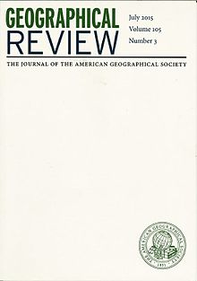
Journals
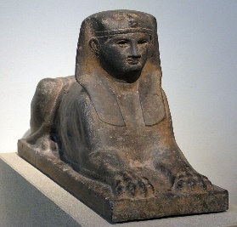
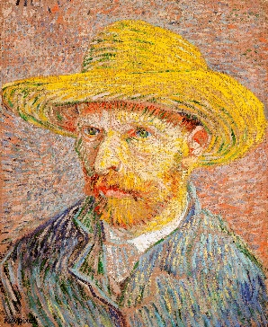
Films
Paintings
Books
Artefacts
Newspapers
3. What are the benefits, value & positive aspects?

Task:
Pick out any points from the sources you have gathered that will help you build up a case for cancel culture and write these below.

....................................................................................................................................................................................................................................................................................................................................................................................................................................................................................................................................................................................................................................................................................................................................................................................................................................................................................................................................................................................................................................................................................................................................................................................................................................................................................................................................................................................................................................................................................................................................................................................................................................................................................................................................................................................................................................................................................................................................................................................................................................................................................................................................................................................................................................................................................................................................................................................................................................................................................................................................................................................
4. What are the weaknesses or negative aspects?

Task:
Look at the sources of information that you have gathered and pick out all the aspects that would help you to build up a case against cancel culture.

……………………………………………………………………………………………………………………………………………………………………………………………………………………………………………………………………………………………………………………………………………………………………………………………………………………………………………………………………………………………………………………………………………………………………………………………………………………………………………………………………………………………………………………………………………………………………………………………………………………………………………………………………………………………………………………………………………………………………………………………………………………………………………………………………………………………………………………………………………………………………………………………………………………………………………………………………………………………………………………………………………………………………………………………………………………………………………………………………………………………………………………………………………………………………………………………………………………………………………………………………………………………………………………………………………………………………………………………………………………………………………………………………………………………………………………………………………………………………………………………………………………………………………………………………………………………………………………………………………………………………………………………………………………
5. Alternative & creative ideas

Task: What’s the alternative to cancel culture? Add your ides below:

……………………………………………………………………………………………………………………………………………………………………………………………………………………………………………………………………………………………………………………………………………………………………………………………………………………………………………………………………………………………………………………………………………………………………………………………………………………………………………………………………………………………………………………………………………………………………………………………………………………………………………………………………………………………………………………………………………………………………………………………………………………………………………………………………………………………………………………………………………………………………………………………………………………………………………………………………………………………………………………………………………………………………………………………………………………………………………………………………………………………………………………………………………………………………………………………………………………………………………………………………………………………………………………………………………………………………………………………………………………………………………………………………………………………………………………………………………………………………………………………………………………………………………………………………………………………………………………………………………………………………………………………………………………………………………………………………………………………………………………………………………………………………………………………………………………………………………………………………………………

6. Coming to a conclusion

Task A:
Organise your thoughts and ideas by filling in the plan below. Consider the limitations of each of your points, drawing on reasons, facts and/or examples where possible. Arrange your points in priority order.

Make your case for or against cancel culture:

Points for: | Points against:
Conclusion (conclude with a reasonable statement which includes exceptions):

Task B:

Write a blog or a script for a vlog about your opinion on the topic of cancel culture using the plan you have just made.

………………………………………………………………………………………………………………………………………………………………………………………………………………………………………………………………………………………………………………………………………………………………………………………………………………………………………………………………………………………………………………………………………………………………………………………………………………………………………………………………………………………………………………………………………………………………………………………………………………………………………………………………………………………………………………………………………………………………………………………………………………………………………………………………………………………………………………………………………………………………………………………………………………………………………………………………………………………………………………………………………………………………………………………………………………………………………………………………………………………………………………………………………………………………………………………………………………………………………………………………………………………………………………………………………………………………………………………………………………………………………………………………………………………………………………………………………………………………………………………………………………………………………………………………………………………………………………………………………………………………………………………………………………………………………………………………………………………………………………………………………………………………………………………………

