Skills for STEM subjects
Workshop

Student Booklet

1. Starter – look at the 3 posters on the following pages.

- What are your first impressions of these scientific posters?
- Which one catches your eye?
- Which one do you like? Why do you like it?

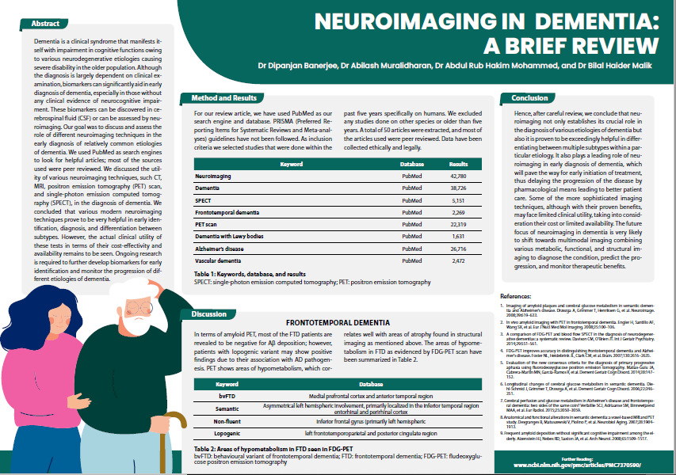
1.

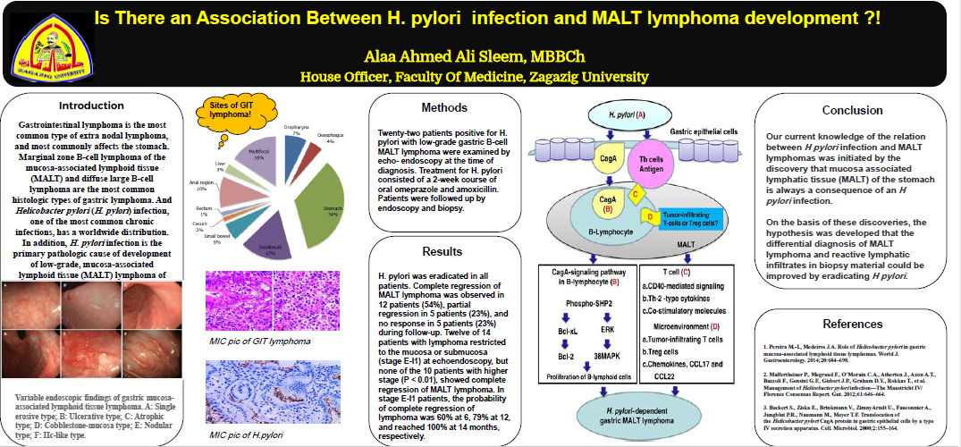
2.
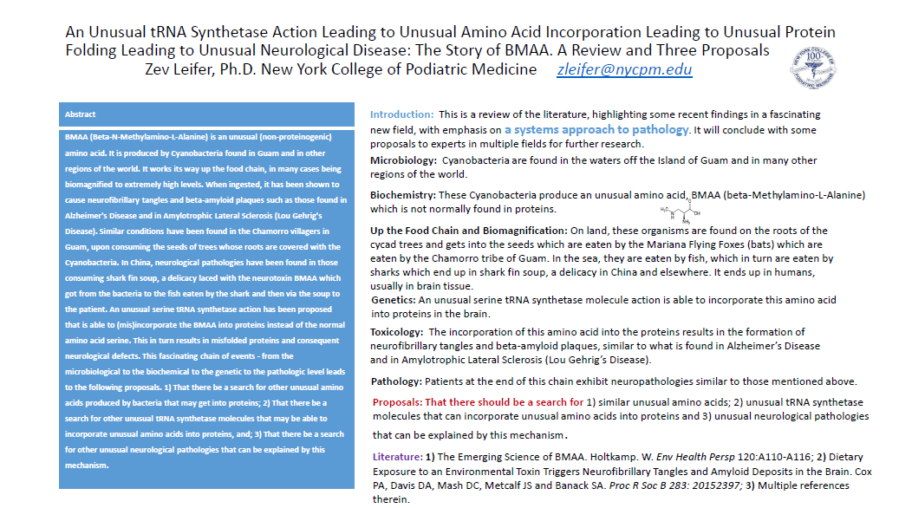
3.
2. What does a good scientific poster look like?

Task:
- Find 2 more examples of scientific posters by visiting: https://www.eposters.net/

- Evaluate the posters using the criteria in the grid below.

Criteria | Poster 1 | Poster 2
Text
Limited text – only headline information
Information is carefully selected – key points rather than key sentences
Clear narrative of research
Diagrams & Images
Information presented in diagrams rather than words
Diagrams are clear
Images are relevant
Structure & Design
Flow of poster is logical – begins with aims and objectives & flows downwards in columns to methods, results, conclusions & references.
Poster is not overly-embellished with formatting and pictures.
Effective colours used, contrasting backgrounds (e.g. blue and yellow, black and white) to ensure text is easy to read.

3. Creating your own scientific research poster

Task: Choose an article from the options below and click on the link to read.

Article 1: Giraffe genome holds keys to its peculiar body—and clues to hypertension treatments:

https://www.sciencemag.org/news/2021/03/giraffe-genome-holds-keys-its-peculiar-body-and-clues-hypertension-treatments

Article 2: Honeybees rally to their queen via’ game of telephone’:

https://www.sciencemag.org/news/2021/04/honey-bees-rally-their-queen-game-telephone

Article 3: Food supplements that alter gut bacteria could ‘cure’ malnutrition:
https://www.sciencemag.org/news/2021/04/food-supplements-alter-gut-bacteria-could-cure-malnutrition

4. Creating a glossary of key terms:

Task:
- Re-read your chosen article.
- Select any scientific vocabulary to create a glossary (alphabetical list of vocabulary) of the key terms from your selected topic/article.

Term | Definition
…………………………………… | …………………………………………………………………………….  …………………………………………………………………………….
…………………………………… | …………………………………………………………………………….  …………………………………………………………………………….
…………………………………… | …………………………………………………………………………….  …………………………………………………………………………….
…………………………………… | …………………………………………………………………………….  …………………………………………………………………………….
…………………………………… | …………………………………………………………………………….  …………………………………………………………………………….
…………………………………… | …………………………………………………………………………….  …………………………………………………………………………….
…………………………………… | …………………………………………………………………………….  …………………………………………………………………………….

5.Note-taking techniques:

Task:
- Choose the video below which matches the research topic you have chosen for your poster.
- Watch the video and make notes using the Cornell note-taking method.

Topic 1: How did the Giraffe get it’s long neck: https://youtu.be/ER4GqBx_YHM

Topic 2: Honeybee communication: https://www.youtube.com/watch?v=bFDGPgXtK-U

Topic 3: Food that fuels the microbiome to combat malnutrition: https://www.youtube.com/watch?v=ThmdsHJ4g2g

Cornell note-taking method

……………………………………………………………………………………………………………………….

……………………………………………………………………………………………………………………….

……………………………………………………………………………………………………………………….
……………………………………  ……………………………………  ……………………………………  ……………………………………  ……………………………………  ……………………………………  ……………………………………  …………………………………… | …………………………………………………………………………….  …………………………………………………………………………….  …………………………………………………………………………….  …………………………………………………………………………….  …………………………………………………………………………….  …………………………………………………………………………….  …………………………………………………………………………….  …………………………………………………………………………….  …………………………………………………………………………….
……………………………………………………………………………………………………………………….

……………………………………………………………………………………………………………………….

……………………………………………………………………………………………………………………….

……………………………………………………………………………………………………………………….

……………………………………………………………………………………………………………………….
Mind-mapping

6. Creating your own scientific research poster

Checklist:

Limited text

Headline information only

Information presented in diagrams rather than words

Clear diagrams

No irrelevant images

Careful selection of information

Clear narrative of research

