**Wadham College Grant Application Form**

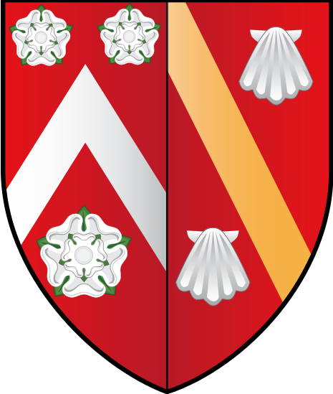

**Holbrook and Bickley Rogers Fund**

|  |
| --- |
| **Applicants -** All students who are reading Classics, Ancient History and related joint schools.  **Purpose -** Contribution to course-related activities, including pre-matriculation courses, summer courses and trips to conferences.  **Quantity –** Discretionary, on the same basis as the Education Support Fund.  The fund will contribute up to £300, with the option of 50% of the remaining required amount up to a maximum total of £600 (depending on availability of funds, and if so agreed by the committee).  Typically up to £600 for those going to courses at the British Schools of Athens or Rome.  **How to apply** – Make an application to the **Education Support Fund**, and highlight that you are studying Classics, Ancient History and related joint schools, and if you are attending a course at the British School in Athens or Rome.  For guidance notes of academic related grant applications click on link below  [**https://admin.wadham.ox.ac.uk/media/documents/GuidanceNotesforAcademicGrants.pdf**](https://admin.wadham.ox.ac.uk/media/documents/GuidanceNotesforAcademicGrants.pdf) |

Forms must be typed and emailed to [fbsec@wadham.ox.ac.uk](mailto:fbsec@wadham.ox.ac.uk) by the Friday of 5th week.   
A confirmation email will be sent upon receiving the application form.

Applications will go forward to the Loans and Grants Committee who will decide on the outcome of the application in 7th week of each term.

Once confirmed, receipts will be required as proof of claim and should be emailed to [fbsec@wadhamox.ac.uk](mailto:fbsec@wadhamox.ac.uk)

All grants will be paid as a credit to the student’s battels account.